We know many apps are available on the market to make the scoring easier. The concern was, after a player starts scoring on his phone, and then had to leave for batting etc, he'll have to leave his phone unlocked with another player to continue the scoring. Many are not comfortable leaving the phone with all the personal information on the phone. This is not a concern anymore and scoring can be continued on another player's phone. So we are dropping the idea of buying a dedicated tablet for the scoring.

- Download following free cricclubs app on your phone/tablet. Available on Apple app store, Google Play and Windows Store. All the players should download the app.
- The app is cloud based so internet connection on the phone/tablet is required while scoring. Estimated 50Mb-100Mb of data may be used for scoring a full 20 overs game. You can check the data usage for each app on your phone before and after the scoring to get a better idea.
- Open the app and search for the club: Montgomery Premier League 2015 and select the club.
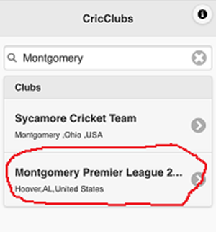
- To setup scoring (right before the game, done by either of the two captains):
  - Select the club (previous step), then select login and login using captain’s user name and password. Make sure you uncheck the Keep me Logged In check box.
  - Select playing 11s for both the teams, change captains if needed, who won the toss, who's batting first and select the name of the scorer (we'll use MPL scorer as name of the scorer for all the games).
  - Select Create Match and then logout.
- Scoring can be done once the match has been created above. For scoring on the app (any player can do this on his phone), select the club (Montgomery Premier League 2015), then select Login and login using user name mplscorer (password will be provided). Make sure you uncheck the Keep me Logged In check box.
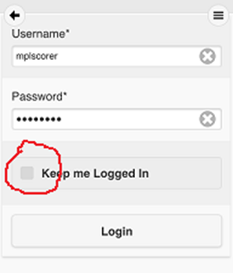
- Select Schedule and select Continue Scoring for your game.
- If you need to change the scorer, simply logout from the app on your phone and let the new scorer follow above steps on his phone and click on Continue Scoring for your game.
- You can also check live scores by selecting Schedule and then your game on the app. No need to login to check the scores.
- Demo for scoring on the app is available here. https://www.youtube.com/watch?v=D0eJ0xARj_o&width=80%&height=90%
- You can also check live scores and other details on the web at http://www.cricclubs.com/MPL2015

