**ASL RULES 2021**

Contents

1. Rules and Regulations 2

2. League and Registration 3

2.1 League Schedule 3

2.2 Team Registration 3

2.3 Violation Discovery 4

2.4 Team Roster 4

3. Format and Match Related Rules 5

3.1 Match Format 5

3.2 Start Time and Duration 5

3.3 Completion of Overs and Slow Over Rate 6

3.4 Substitue Players, Runners and Retiring 6

3.5 Field Setup and Pitch Length (Don’t change Direct Hits – play as per Diagram) 6

3.5.1 Field 8 setup 7

3.5.2 Field 5,6,7 setup 8

4. Tournament Format and Rules of Play 9

4.1 Cancellations, Bad Weather and Match Postponement 9

4.1.1 Points Assignment 9

4.2 Wide Ball 9

4.3 No-Ball Rule (No Free Hit) 10

4.4 Dead Ball Rule 11

4.5 LBW 11

4.6 Mankadding 11

4.7 Wicket Put Down 11

4.8 Recalling a Batsman 12

4.9 Score Cards and Umpire Reports 12

5 Approved Equipment 12

6 Spirit of the Game 13

7 Awards and Trophies 13

8 Umpire Duties 14

9 Captain Duties 14

# 1. Rules and Regulations

* ASL organizing team is responsible to formulate all rules and regulations.
* Each team has to provide a group picture of all 15 players (outside players)/20 players (only subdivision). All the team pics needs to be updated by captain or individual players(profiles).

|  |  |
| --- | --- |
|  | |
|  |  |

•

* Most of the rules are covered by this document. The ASL organizing team will make a decision to add/update modify or delete any rule or guidelines during the season if deemed necessary.
* Any changes made to the rules during the season will be communicated to all participating members/players by their respective captains.
* At any point of the tournament if a team is found guilty or violating these rules will be disqualified from the tournament and the game would be handed over to the opponent team. No changes to already concluded games. The team would not be allowed to register the following year.

|  |  |
| --- | --- |
| **Note: 10th player coming still in parking lot and not physically present in ground, not accepted by ASL. If opponent captain accept, ASL does** | |
| **not have any issue.** |  |

* A team can choose either 9 or 10 players (Including 2 from outside .Any 9 can field and Any 9 can bat and Any 9 can bowl. **If you want to use 10-player option then all players should be physically present before start of the game**. 10th player can bat directly without fielding or bowling at all. 10th player can take breaks (sit out) during bowling or fielding without any restrictions. •

# 2. League and Registration

## 2.1 League Schedule

* The start and end dates for the initial rounds and semis/finals are made known via the schedule distributed in WhatsApp group
* The schedule specifies mandatory umpiring requirements where applicable and the teams must strictly follow the umpiring requirements.
* Requests for rescheduling games may not be entertained. Rescheduling may be possible if opponent captains agrees and they may have to coordinate with other team captains to match date/timings and Umpiring teams.
* Cancellation of the Game due to bad weather (organizing team determines the wash out) will be rescheduled (based on ground availability) one time, second washout for the same game will be considered as draw and teams share points. Rescheduled games might be on Saturday or Sunday depending on the ground availability

## 2.2 Team Registration

* The registration fee for the season is **$300 and $200 for Umpiring deposit.**
* **Umpiring deposit amount will be refunded once teams show up to all their umpiring assignments**
* Payment must be received before the start of the tournament
* All the 20 player names and email addresses must be provided at the time of registration. Email address would be used to complete electronic signature of the waiver form and to communicate league updates. Captain and coordinator phone numbers are also mandatory at the time of registration. We will be using online tool for scoring.
* Captain has to ensure, each player profile is update in the online tool. Opposite team right to stop the play, if profile picture is missing.
* The team captains will be held responsible for any violation of this rule and the team will be disqualified from the tournament. A player can play in only 1 team.

## 2.3 Violation Discovery

* Each team Captain Responsibility to check on the opponent team roster or raise concern about the players of the opponent team and has the right to check the IDs of the players. If any foul play discovered before the start of the

match, the umpire will call the game off and award the game and corresponding points to the opposing team.

* If such an incident takes place and is discovered during a match in progress, the umpire will have no choice but to stop play, call the game off, and award the game and corresponding points to the opposing team.
* If discovered after the game has been completed, the opposing team may file a written complaint to the league. If such a case is found to be true and proven, the offending team will lose the game, and corresponding points will be awarded to the opposing team
* Any team found violation of above rules mentioned, could face termination/disqualification from league at the discretion of ASL Organization team with immediate effect.

## 2.4 Team Roster

* Each team can have a maximum of 20 players on roaster
* All the players from team roaster should sign waiver form before start of the first match. It’s the team captain responsibility to ensure each player sign the waiver form. Team will not be allowed to play first game until all the players (even if that player is not playing first match) on the roaster sign the waiver form
* Each player playing in playoff games must have played at least 25% of the league games including washout games. Playing 9/10 must be provided within 24 hours of the washout game.
* A team can choose either 9 or 10 players (Including 2 from outside) for any game. Any 9 can field and Any 9 can bat and Any 9 can bowl. If you want to use 10-player option then all players should be physically present before start of the game. 10th player can bat directly without fielding or bowling at all. 10th player can take breaks (sit out) during bowling or fielding without any restrictions.

# 3. Format and Match Related Rules

## 3.1 Match Format

* All matches will be played as one inning per side.
* Each inning will consist of 15 Overs unless it’s a shortened match due to weather or any other situation, umpires will decide the Number of overs per innings before the first ball of the match is bowled. The captains should keep in mind the ground timings before making a decision on the Number of overs per innings. Both teams have to play same number of overs for a result.
* A bowler will be allowed to bowl no more than 4 overs. In case the total number of overs gets reduced due to late start or rain, the maximum limit per bowler shall be determined by the playing team’s captains and umpires.
* Each team will be required to bowl the allotted 15 overs in no more than 1 hour and 15 mins.
* No last man batting is allowed. This holds true even if the team has less than 9 players in the playing roster

## 3.2 Start Time and Duration

* Both teams should be at the ground 30 mins before start of the match and toss should happen 15 mins before start of the match.
* Both teams are responsible for setting up the field and boundary markers.
* If both teams are not ready by scheduled time, the overs will be reduced in order to make up for the time Umpires and Captains will decide overs based on first ball time. For every 10 min delay reduction of 1 over. Ex: 10 mins delay it will be a 14 over game, 20 mins delay it will be a 13 over game, 30 mins delay it will be a 12 over game and so on.
* If only one team (min 6 players) comes on time (15 minutes before game starts), then they will be automatic winner of the toss.
* After the toss is over, teams cannot delay the game. Teams have to start the game with the players available on the ground.
* If both teams are not ready to play 60 minutes after start time, then the match will be counted as a loss for both teams, and no points will be awarded to both the teams
* In case of a delayed start, the umpire and both the captains should agree to the start time of the game and the number of overs to be bowled per innings.
* It is a reserved field then the reservation time needs to be considered. The maximum overs per inning cannot be modified once the game has started.

## 3.3 Completion of Overs and Slow Over Rate

• . Under normal circumstances, timely start and without rain delays and interruptions, all teams must bowl their allotted overs in the scheduled time

## 3.4 Substitue Players, Runners and Retiring

* Retired player – A player can retire at any point of time during the batting and can bat again after a wicket is fallen.
* No bye-runner is allowed for any team, even if there is an injury to the player. • Substitute (Who is not the playing list) can only filed but not bat or bowl.

## 3.5 Field Setup and Pitch Length (Don’t change Direct Hits – play as per Diagram)

* The pitch length should be 22 yards/66 Feet Stumps to Stumps.
* The pitch length should be verified by both captains and umpire BEFORE the start of the game and cannot be modified once the play has started.
* ASL strongly recommends all the team to carry a measuring tape at least for 250 feet and it should be used for measuring the pitch length.
* A batting side stump should be kept minimum 20ft from the behind/backwall fence and maximum of 30ft distance.
* There should not be more than 4 fielders on any side of the field (Off/Leg side) at any point of Time. . Ex: 3 fielders on off side / 4 fielders on leg side excluding wicket keeper and bowler 3 fielders on leg side / 4 fielders on off side excluding wicket keeper and bowler. Should not consider bowler at any time, irrespective of the bowler, bowling over or around the wicket.

|  |  |
| --- | --- |
| Note: Don’t change Direct Hits and play, which will reduce your total runs from other | |
| teams and in turn will affect your overall run rate calculations. | Please follow below |

diagram settings on run scorings

### 3.5.1 Field 8 setup

• Field setup for SharonSprings field 8 is below

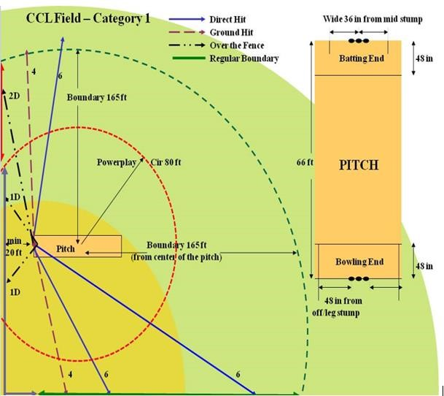

### 3.5.2 Field 5,6,7 setup

• Field setup for Sharon Springs field 5,6 and 7 is as below

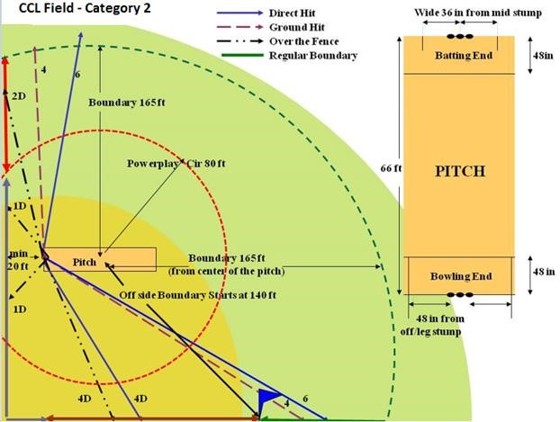

# 4. Tournament Format and Rules of Play

## 4.1 Cancellations, Bad Weather and Match Postponement

* In case of inclement weather the assigned officiating umpire along with the playing captains will make the decision regarding the game.
* Teams are expected to show up for all the scheduled games, and the umpire(s) along with the playing captains on the field would make a decision whether the playing conditions are favorable to play or not. Failure to show up for the scheduled game by any side will be considered as "forfeiting the game".
* If both the teams are not ready to play due to bad weather or weather interference during any part of the match (outcome of the match not determined by the allotted time), then the match will be registered as a No Result to both the teams and 2 points will be awarded to each team.
* For rain washout games, we will try to reschedule one time depending on the availability of the grounds and it might have to be played Sunday or Saturday and in some cases (if ground is not available or weather related), the points has to be shared. Playing 9 must be provided within 24 hours of the washout game.

### 4.1.1 Points Assignment

The following point system will apply:

* The winning team will get 4 points and losing team will get 0 points.
* In case of a Tie or No Result, each team will get 2 points.
* Teams which forfeit the match will get 0 points.

## 4.2 Wide Ball

* Wide markers should be set up before the start of the game and should be set up as follows: Off side wide marker should be placed at 36 inches (3 ft.) from the middle stump. Anything on leg side is wide considering ball crosses the leg side in batsman’s normal standing position. The umpire will verify the setup. • Any ball over the marker is not considered a wide.
* Wide should be called by the main umpire if he feels the ball crossed the plane of the batsman outside the marker. It does not matter where the batsman is at that time.
* Stumping is considered out in wide ball and an extra run will be added to the batting side score. The bowler has to bowl an additional ball.
* After first bounce if the ball is above the head of the batsman standing upright on the crease, then the umpire may call it a wide(Obviously ball should not touch any part of batsman otherwise it will be called as no-ball).

## 4.3 No-Ball Rule (No Free Hit)

* Fair delivery feet

The bowler’s front foot must land with some part of the foot, whether grounded or raised, behind the popping crease

The bowlers back foot must land within and not touching the return crease (side crease).

Only the back leg should be considered for a no ball for return crease (side lines).

* Any delivery, which passes or would have passed on the full above waist height of the striker standing upright at the crease is to be deemed dangerous and unfair, whether or not it is likely to inflict physical injury on the striker and can be called as a No Ball. Over the waist no ball should be considering if it passes the stump in the same height. If a batsman gets bowled, then it’s out.
* After first bounce if the ball is above the shoulder height of the batsman standing upright on the crease, then the umpire may call it a No Ball. (**No warning rule)**
* If, in the opinion of either umpire, the ball has been thrown, he shall Call and signal No ball.
* Caution the bowler, when the ball is dead. This caution shall apply throughout the innings.
* Inform the other umpire, the batsmen at the wicket, and the captain of the fielding side and, as soon as practicable, the captain of the batting side of what has occurred.
* If either umpire considers that after such caution a further delivery by the same bowler in that innings is thrown, the umpire concerned shall repeat the procedure set out in (a) above, indicating to the bowler that this is a final warning. This warning shall also apply throughout the innings.
* If either umpire considers that a further delivery by the same bowler in that innings is thrown,
* The umpire concerned shall call and signal No ball. When the ball is dead he shall inform the other umpire, the batsmen at the wicket and, as soon as practicable, the captain of the batting side of what has occurred
* The umpire at the bowler's end shall direct the captain of the fielding side to take the bowler off forthwith. The over shall be completed by another bowler, who shall neither have bowled the previous over nor be allowed to bowl the next over. The suspected bowler thus taken off shall not bowl again in that innings.

## 4.4 Dead Ball Rule

* If a bowler bowls a ball that makes two bounces before the stumps on the batting side, and then the ball should be called a Dead ball by the umpire • Any kind of batsman dismissal, scoring rule is invalid with Dead Ball.
* If a fielder is not trying for run out i.e. when a fielder pass the ball to keeper and from then the ball is dead.
* It is unfair if the wicket-keeper standing back makes a movement towards the wicket after the ball comes into play and before it reaches the striker. In such a scenario either of the umpires can signal Dead ball.

## 4.5 LBW

* There will be no LBW
* However runs for leg byes are allowed as long the batsman does not deliberately pad.

Note: There is no such rule saying batsman not offered any stroke. As long as not deliberate padding batsman can have leg bye. For Example if a batsman tries to avoid a bouncer and if it hit his body, there is always run for that.

## 4.6 Mankadding

* Mankadding is allowed but only after a legitimate warning by the umpire to the bowler and/or the captain of the fielding team. Mankadding means, bowler attempting to run out the non-striker before entering the delivery stride. The umpire should then warn the non-striker. Also the bowler should NOT have completed his bowling action (bowler should NOT have entered his delivery stride) in order to make an attempt for Mankadding.
* If the non-striker continues to run after 1 warning and the bowler runs nonstriker out and the non-striker can be declared out Mankadding if umpire think he was out of his crease.

## 4.7 Wicket Put Down

* Regular run out rules apply. If all the stumps are put down on the ground, then following two situations apply.
* If regular stumps are used, then one or more stumps has to be put back before run out is made or one of the stump need to be carried by hand with ball in the same hand.
* If spring based stumps are used, then the entire stump pack has to be brought upright before run out is made or the entire stumps to be carried by hand with ball in the hand. This also applies when the base moved but wicket didn’t fall.

## 4.8 Recalling a Batsman

• Once a batsman is declared out by the umpire, umpire can revoke the decision before batsman gets out of the field or the fielding captain can recall the batsman by informing it to umpire. Umpire can change the decision, without consulting fielding captain.

## 4.9 Score Cards and Umpire Reports

* Scorecards for all games must include the full batting, bowling, and fielding records.
* Both captains are responsible for providing and completely filling in the entire statistics from their innings (this includes their batting and the other teams bowling and fielding details) to the umpires.
* Teams are urged to put names of fielders involved in a dismissal on the scoresheets.

# 5 Approved Equipment

* ASL will provide teams with approved balls which must be used during official games. Each innings should be started with a new ball. No exceptions.
* Any team found not using the standard ball or not in possession of a NEW ball at the start of their bowling inning shall forfeit that game.
* All teams must provide at least one spring base stumps before the game is started.
* Score sheets will be given to captains and umpires must send the completed scorecard with results and signatures from team captains to the ASL WhatsApp group. The scoresheet is also available for download on the website.

# 6 Spirit of the Game

* Cricket is a game that owes much of its unique appeal to the fact that it should be played not only within its Laws but also within the Spirit of the Game. Any action, which is seen to abuse this spirit, causes injury to the game itself. The major responsibility for ensuring the spirit of fair play rests with the captains
* Captain’s Responsibility
* The captains are responsible at all times for ensuring that play is conducted within the Spirit of the Game as well as within the Laws. • The responsibility for the team’s conduct firmly lies with the captain

# 7 Awards and Trophies

* Each registered player (up to 18) of winning side will receive a champion’s trophy/medal.
* Each registered player (up to 18) of the losing side will receive a runner’s trophy/medal.
* Individual man of match awards for Semi-Finals and Finals may also be given.

# 8 Umpire Duties

* Team captains should send best possible Umpires.
* Umpires need to report to the ground at least 30 mins before start of the match.
* Umpires needs to make sure ground is setup properly before start of the match
* Umpires should collect playing 9/10 names on the scoresheet and verify the names against roaster
* Toss should happen 15 mins before the start of the match
* Umpires should collect scoresheets from both teams, make sure they are accurate and correct, and take signatures of both captains. Umpires should email the score sheets to info@atlcricket.org and captains should post in ASL WhatsApp group.
* If any of the team, captains raises concerns on the playing 9/10. Its umpires and opponent team captains’ duty to prove the playing 9/10 mentioned on the roaster.

# 9 Captain Duties

* All team captains should come to the ground with one set of Stumps, • Tape and Cones for Boundary and wides.
* Ground setup is the responsibility of Home Team Captains.
* Once you are at the ground Fill out the score sheet with playing 9/10 and hand over to Umpires.
* Captains should post a pic of your team (playing 9/10) in ASL WhatsApp group. Applicable to both Teams playing the game and post in WhatsApp group.
* If both Captains agree a 5 mins break can be taken after 8 overs in each innings.
* After the game is over it’s the responsibility of both Captains to collect the stumps, cones and clean up the ground immediately.
* Team captains should send best possible Umpires.
* Team captains should share the ASL team’s roaster to organizing team well before the start of the first game no exception and not on the game day.
* Team captain has the right to verify the ID’s of all players from opposition team and make sure they are from the same team and on the roaster provided. Captain should inform organizing team and Umpires if there is any discrepancy
* Captains should post score sheets in ASL WhatsApp group