Cricket for Cure T20 Tournament
Playing Conditions

Effective July 15, 2024

For the tournament, if games are interrupted by natural events, including but not limited to rain, tornadoes, storms, or other acts of God, management will make reasonable efforts to reschedule the games, subject to the availability of the grounds. However, rescheduling is not guaranteed, and all fees are non-refundable.
We will follow MYCL/WYCL Guidelines for this tournament with the following exceptions:
Category | Ball (Pink) | No of Overs | Overs limit for a bowler | Balls limit in an over | Pitch | Boundaries | inner circle | Power Play
U11 | Youth ball/4.75 ounces | 20 | 4 | 8 | 21 yards | 45 yards | 20 yards | 6
U13 | Adult ball/5.5 ounces | 20 | 4 | no limit | 22 yards | 50 yards | 25 yards | 6
U15 | Adult ball/5.5 ounces | 20 | 4 | no limit | 22 yards | 55 yards | 30 yards | 6
Vinyl | Vinyl Ball | 20 | 4 | 8 | 16 yards | 30 yards | N/A | N/A

Divisions and Age limits:
a. U11: A male player must have been born after August 31, 2012. Female players must have been born after August 31, 2010.
b. U13: A male player must have been born after August 31, 2010. Female players must have been born after August 31, 2008.
c. U15: A male player must have been born after August 31, 2008. Female players must have been born after August 31, 2006.
d. Vinyl: A female player must be born after August 31, 2010, to play and at the same time boys who are born after August 31, 2012, are eligible.
Note: Boys who already played hard ball cricket are not eligible to play in this division. A minimum of two females need to in the playing 11.
Field size
a. U11: A circle, with radius 45 yards from the middle of the pitch. The straight boundaries are 34.5 yards from the rear of each wicket.
b. U13: A circle, with radius 50 yards from the middle of the pitch. The straight boundaries are 39 yards from the rear of each wicket.
c. U15: A circle, with radius 55 yards from the middle of the pitch. The straight boundaries are 44 yards from the rear of each wicket.
d. Vinyl: A circle, with radius 30 yards from the middle of the pitch. The straight boundaries are 22 yards from the rear of each wicket.
Field restriction shall apply:
a. Two semi-circles shall be drawn on the field of play. The semi-circles shall have as their center the middle stump at either end of the pitch. The radius of each of the semi-circles shall be as indicated below, with two parallel straight lines drawn to link the semicircles. (See sections field dimensions) i. U11: 20 yards
ii. U13: 25 yards.
iii. U15: 30 yards
6 overs are the cut off points for which no more than two (2) fielders shall be allowed outside the restricted area, after which, no more than five (5) fielders are allowed outside the restricted area.
If for some reason team is playing with less than 11 players, they still need to follow the above field restrictions.
Shortened matches:
Minimum of 5 overs
Field restrictions shall be 30% of the total overs (Normal rounding rules apply i.e. 2.4 becomes 2, and 2.5 becomes 3)

Forfeit or “No Show” Games
In the event of a game is forfeited by any team there will penalty of 2 points
Supersub (We do not have impact player rule for this tournament)
Supersub is allowed in all the age categories.
- A super sub must have batted or bowled in the match to considered as “played in the match”
- Before the coin toss, teams must provide the names of the team including super sub
- Super sub can bat, bowl and act as wicket keeper and can come on at any point in time provided all the 10 wickets are not down and only 11 players are on the field.
- The replaced player will be able to come back and bat and bowl and keep wickets, subject to the limitation that there will only be 10 outs and only 11 players on the field.
Super Over
- In the event of a tie, the following will apply:
- One Super over match will take place on the same ground.
- Prior to the commencement of super over, each team elects three batsmen and one bowler
and nominated players are given in writing to the game umpires.
- Umpires select which end to bowl from and both teams use the same end to bowl & bat
their over. No Umpire change.
- Team batting second in the match will bat first in the one over eliminator.
- Same ball used in their inning will be used. No ball change.
- No field placement restrictions. The Super Over shall be played with the same fielding
- restrictions as would be applicable for the last over in an uninterrupted match.
- During the League Stages of the playoffs, In the event of the teams having the same score after super over (tied) has been completed, subsequent super overs will be conducted unless a winner is decided.
- If the Super Over is tied, then subsequent Super Overs will be played until there is a winner.
- In normal circumstances, any subsequent Super Over will start 5 minutes after the previous Super Over ends. The interval shall be 5 minutes.
- The team batting second in the previous Super Over will bat first in the subsequent Super Over.
- The balls selected for use by each team in the previous Super Over shall be used again by the same team in subsequent Super Overs.
- The fielding side must bowl it’s over in a subsequent Super Over from the opposite end to which it bowled from in the previous Super Over.
- Any batsman dismissed in any previous Super Over shall be ineligible to bat in the following Super Over.
- The bowler who bowled the over in the previous Super Over shall be ineligible to bowl the over in the subsequent Super Over.
- All other playing conditions will be the same as for the initial Super Over. In case a super over cannot be played due to weather conditions, bad light, etc., a league stage game will be concluded as “No result” and both teams will receive 1 point.
Umpiring
Please respect the umpire’s decisions. We will have one neutral umpire at the game who will be responsible for making decisions, square leg umpire will be a parent (other than the team coach) from the batting side. The Main Umpire decision will be final, they will take all the calls in collaboration with the organizer at the game.
Points:
a. Match result: Win= 2 points, Tie= 1 point, Abandoned = 1 point, Loss= 0 points.
b. Points will be awarded to the side that has won the match due to forfeiture, or if the other side is not ready to play or do not have enough players to start/resume by the cut-off point of 30 minutes after the scheduled start time/resume time.
Play offs Format
Top two teams will meet in the Final. If two teams have same points, net run rate will be taken into consideration to decide the top 2 teams.
Field Dimensions: Outer Boundary, Inner Circle and Pitch Length. (All dimensions are in yards)

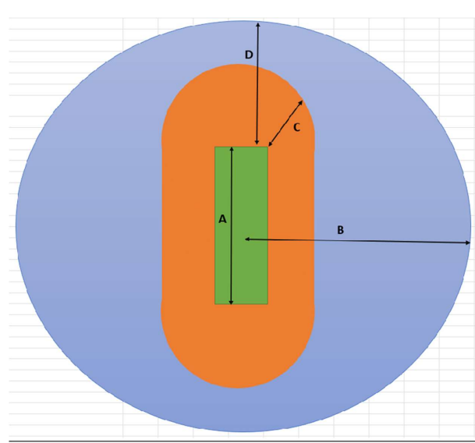

League | A | B | C | D
U11 | 21 | 45 | 20 | 34.5
U13 | 22 | 50 | 25 | 39
U15 | 22 | 55 | 30 | 44
Vinyl | 16 | 30 | n/a | 22

Note: To make sure that the games are complete in the stipulated time, all the games will be played from one side of the wicket.

