  - General Rules
- Teams must report 15 minutes prior to their first game. Schedule will be strictly followed and teams reporting late will be deducted 1 over for every 5 minutes
- Registration fees are $130 per team. All payments are due before your first game
- Max 8 players are allowed per game and 11 in roster. No player can play for more than one team. In the event a team uses a player from a different team, their winnings in such disputed games will be forfeited
- Max 7 overs for each innings and no Last Man
- Minimum 4 bowlers must be used. A bowler will be allowed a maximum of 2 overs
- Nivia brand hard tennis ball will be used for the tournament. It will be made sure both the innings in a game will be played with the same brand of Hard Tennis Balls
- All games will be played on Soft Ball Fields
- The distance between wickets will be 22 yards. Three stumps to a spring base will be placed on the batting side, and on the bowler side
- We will provide neutral main umpire for each game. The Batting Team Captain would nominate a Leg Umpire from his team if we cannot provide a second neutral umpire
- In an event of dispute, the main umpire’s decision is final. The main umpire has the authority to overrule the leg umpire’s decision at any point of the game
- A new ball will be provided at the beginning of each inning for all the games
- If there is a dispute of any sort with any call, Organizers call will be final
- Sledging is strictly not allowed. Verbal abuse, use of profanities etc. directed at players of the opposing team will result in penalty or suspension of the players. Under no circumstances should the safety of the players be jeopardized
- There will be several designated areas for garbage disposal. Water bottles and other trash items should be disposed in the designated areas only. Each team captain is responsible to make sure your team members comply
- All the teams should sign the waiver form before the first game
- The tournament committee reserves the right to amend the rules at any time if it considers such action to be in the best interests of the competition. Committee holds the right to cancel any team for misconduct
- Organizers are not responsible for accidents or injuries that a player may suffer while traveling to/from the grounds, while playing, or even simply watching a game.
- Organizers will not be held liable for any accidents or injuries that a player may suffer while traveling to/from the grounds, while playing, or even simply watching a game.
- Please comply with park policies, strictly no SMOKING and no ALCOHOL and no Loud Music

  - Points System and Play-Offs Format
- 18 Teams will be divided into 6 Groups through a random draw (A, B, C, D, E and F) with 3 teams in each group
- In the league games, winning team gets 2 points
- In case of an abandoned or tied game in the League stage both teams shall receive one point each
- In case of a no show from one of the teams, the other teams will be awarded 2 points and no impact on NRR for a forfeit game
- The criteria of seeding (league stage, priority-wise) are:
  - Points
  - NRR
  - Head-to-head
  - Coin Toss
- Top Eight (8) teams form the playing 18 teams will automatically qualify for Knock Out round.
  - The ranking of the teams in league stage are used for seeding Quarter Final teams
    - QF1 = Rank 1 vs Rank 8
    - QF2 = Rank 2 vs Rank 7
    - QF3 = Rank 3 vs Rank 6
    - QF4 = Rank 4 vs Rank 5
    - SF1 = Winner of QF1 vs Winner of QF4
    - SF2 = Winner of QF2 vs Winner of QF3
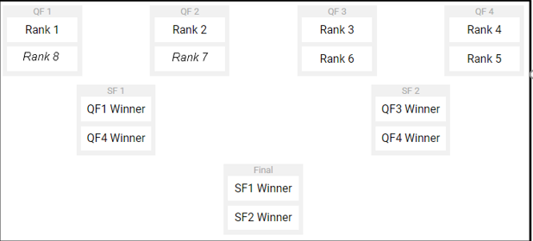
- Tied games in Quarterfinals, Semi-finals and Finals will be decided by “Super Over” where each team will send 1 bowler to bowl, and for the batting side, 3 batsmen (i.e. 2 wickets/outs), highest score during the super over wins the tie. No field restrictions or Power Play in Super Over. If the super over is a tie, winner is decided by the highest number of boundaries (4’s and 6’s combined) and then a coin toss if the number of boundaries is also a tie

  - Game Rules
- All the traditional cricket rules apply. Some rules that may differ are as follows
- First two overs of the innings will be powerplay. Only two fielders allowed outside inner circle
- Rules related to LBWs/Byes/Overthrows:
  - No LBWs (leg before wicket) and no leg byes. A batsman cannot be run out while attempting a leg-bye
  - Normal byes and overthrows are applicable
  - If the ball gets stuck in the fence in the event of an overthrow, the batsmen must complete the run without getting run out and an additional run is declared (1D)
  - The one declared stays even if the ball is retrieved/pulled out of the fence, the batsmen could not be run out if the run is not complete
- No ball rules are normal:
  - Ball clearly above the waist on full or above the shoulder on a bounce (there is NO first bounce warning).
  - Overstepping by the bowler (there is NO free hit for over stepping).
  - Back foot of the bowler crossing the side crease.
  - The bowler fails to give the guard (despite 1 umpire warning per bowler per game)
  - Fielder substituted during the game without notifying the umpire
  - Only ways out for a no ball are run out/hitting ball twice/obstructing the fielder. Any runs scored will be added to the 1 run given for no ball
- Wide ball rules are normal:
  - Only ways out are stumping/run out. The ball delivered is still a wide
  - Any byes taken will be added to the 1 run given for wide ball
- Scoring:
  - If the ball goes over the marked boundary zone directly, 6 runs will be given to the batsman. If the ball rolls to the boundary line, 4 runs will be given to the batsman
  - If the ball goes out of the side/back fence, 1 run will be declared depending on the zone where it crossed the imaginary boundary per the zone as shown in the image below
  - If the ball rolls and goes outside the fence, 1 or boundary runs will be declared depending on the zone where the ball crossed the fence
  - If the ball hits the side/back fence and stays in the field, the batsman can run between the wickets to make runs
  - If the ball stuck in the fence, 1 run is declared. If the ball is stuck in the fence in an event of overthrow, the run in-progress and an additional declare run will be awarded to the batsmen
- Catching rules:
  - Batsman is out if a catch is taken by the fielder who is in contact with the fence. However, the ball should not have touched the fence before or during the catch is taken
  - Batsman is not out if the fielder takes a catch off the bounce from the side fence
  - Batsman is out even if the fielder takes the catch outside the side fence (not beyond the 4/6 boundary line)
- Rules related to substitutions:
  - A fielder can be substituted during the game by notifying the main umpire
  - If a fielder leaves the field for the last X overs in the innings, he will not be allowed to bat for the first X overs
  - A batsman can be substituted ONLY at the end of an over with another not out batsman but can come back in only after all other batsmen are out or retired
  - If a bowler walks out of the field f, the bowler needs to stay on the field for at least 1over before bowling his next over
  - We do not recommend by-runners. But in case of a genuine injury sustained during the game, it will be up to the opposition(fielding) captain to allow by-runners
- The Declared Zone
  - If a fielder attempts a catch and drops it in the declared zone, ONLY the declared runs will be granted. Batsman cannot be run out
  - If the ball goes into the declared zone after touching the fielder (accidentally pushed by the fielder) in the infield, the declared runs (1 or 4/6 depending on zone) will be considered as an overthrow and added to whatever the batsmen run and score
  - Batsmen cannot be run out if the ball is collected after crossing the side/back fence. Declared 1 or boundary runs will be granted
- Damaged/Lost Ball:
  - Damaged/Lost ball shall be replaced with a used ball approximately as old as the previous one
  - In the event where an older ball is not available, you might be provided a new ball (this decision will be made by the Umpire and the Organizers)
  - The delivery during which the ball was torn will be considered a dead-ball and must be re-bowled
- Rain Interruption
  - If rain halts the tournament for a short period, and if the tournament organizers can resume and still complete the tournament closer to the original schedule then the interrupted games will be resumed/replayed per below guidelines:
    - Total wash-out or at least one inning is not complete – the game will start afresh
    - One innings completed, second innings is < 2 overs – the game will start fresh
    - One innings completed, second innings is > 2 overs – continue the game, do not start fresh
  - If the game cannot be rescheduled within a reasonable duration, points will be equally shared
  - Teams are not required to comprise of same players for a re-match
  - The Umpire and Organizers will review the field conditions after rain and could overrule the above statement if required depending on parameters like time available, game status, etc.
- Mankading:
  - The non-striker shall not leave the popping crease before the bowler enters his delivery stride.
  - Mankading is valid after one warning per team by the Umpire

Declared Zone and Boundaries

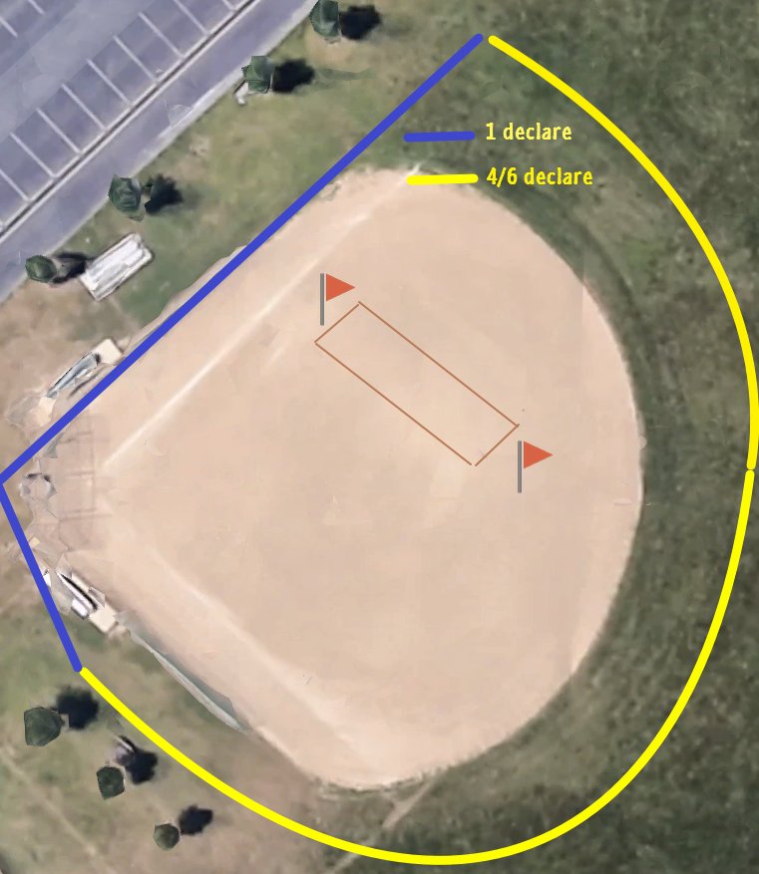

Park Directions

Testerman Park – Maineville – OH
Main Entrance: (Close to fields 1, 2 & 3)
8373 Maineville Rd, Maineville, OH 45039

West Entrance: (Close to fields 4 & 5)
600 Caldwell Dr, Maineville, OH 45039

Registration desk will be setup at shelter behind field 1

