FCC Fall Cricket Tournament
Sept 17th, 2022
T-7 Series Rules & Regulations
Ground Location Guide:

Address: 21410 Lunn Rd, Strongsville, OH, 44149
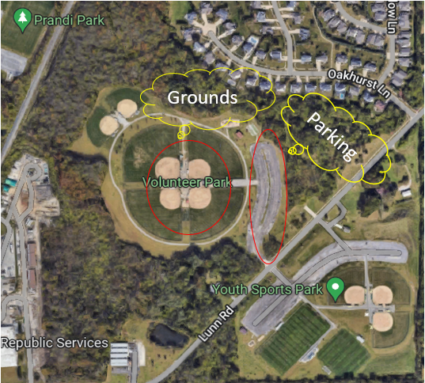

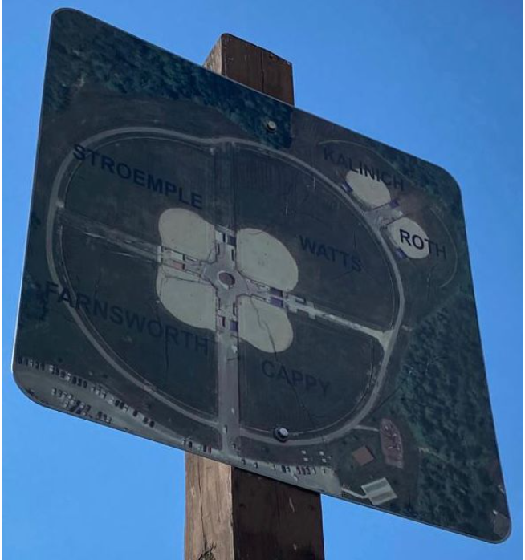
General Rules & Regulations:
- Each team will have a roster of 9 players max.
- Every Player must play at least 1 league match to qualify for eliminators, NO EXCEPTIONS.
- No alcohol or smoking is allowed in the ground.
- Each team must clean up after their games, absolutely no littering. Organizers will provide Trash Bags.
- Teams are required to be on time any time. The toss will happen 5 minutes prior to the schedule time. Team must have 4 players to start game.
- Even after 15 minutes buffer time if any team doesn’t show up with at least minimum 4 players match points will be given to opponent team.
- Teams that have early morning matches, please make sure to be on time and help us to complete the matches on time.
- Each team must finish their 7 overs within allotted time, any delays will be penalized at umpire’s discretion.
- There would be two neutral umpires for each game sent by Organizers.
- Main umpire can override leg umpire.
- Captains shall advise members of their respective teams that the Umpires’ decision is final.
- Player can only play for the registered team and any discrepancy found will result in disqualification of the team(s).
- Playoff qualification will be decided based on net run rate calculations in case of equal points in table.
Tie game Rules:
- Tie-games during league stage will result in 1 point each team.
- Tie-games during playoff will result in super over (bowling team must bat first as per the ICC rules), 2nd Tie-Game will in another super over, but not same batsman or bowler participate. In case of 2nd Super over Tie – it will be League higher rank team will qualify to next round.

Field Restrictions:
- Maximum of 4 fielders are allowed on the boundary.
- Bowlers Limits: A bowler can bowl a maximum 2 overs in a game.
- New batsman will get strike even batsmen cross during a catch out.
- Retired batsman can come back anytime but batsmen can only retire at the end of the over.
- Batsman is out if a catch is taken by the fielder who is in contact with the fence. However, the ball should not be in direct contact with the fence during the catch.
- By-Runners are not allowed (except if player injured in that game provided umpire/opponent captain agree). If any batsman must take By-Runner without any injury, then he must come for batting as the last down.
- Mankading OUT is allowed after one warning for batsman and direct out for By-Runners.
- LBW: This mode of dismissal is not applicable for our tournament. The umpire cannot rule a batsman out LBW. Due to the same leg byes are also not applicable.
- Substitute fielding is allowed only in case of player injury during the game. Substitute cannot bat or bowl. Umpire and Opposite Captain has to agree.
- New ball would be used in each innings. The organizing committee takes the responsibility of providing similar balls in case the ball is lost/damaged.
- Runs over fence: if the ball goes over the short fence it’s 2 runs declared and if it goes over long fence or back side fence it will be declared as 1 run.
No-Ball Rules:
- One bouncer is allowed per over. A bouncer is a ball that bounces above the shoulder and below the head. The second such ball in an over will be called a no ball.
- Only foot No ball is a free hit as per ICC rules.
- Fielder substituted during the game without notifying the umpire.
- Only ways out for a no ball are run out/hitting ball twice/obstructing the fielder. Any runs scored will be added to the 1 run given for no ball.
- Wide ball rules are normal. Ball bouncing above the batsman’s head will be termed as Wide.
Lunch and Refreshments:
- Water and Bananas will be provided by organizers.
- Lunch is not included in the registration fee.
- If required by teams, Lunch menu form will be provided to teams. you can fill the form and pay for lunch separately.
- Paid lunch will be provided from Crown of India.
Note:
- Each captain must bring one of stumps (mandatory)
- Registration fees are non-refundable once admitted in the tournament except a complete washout of the tournament without bowling a single ball.
- The Organizers reserves the right to amend the Rules at any time if it considers such action to be in the best interests of the competition.
- During a match if a situation arises that is not defined in these rules document, then the decision will be taken based on the rules mentioned in the following website. http://www.lords.org/laws-and-spirit/laws-of-cricket/laws/
Grouping and Format:
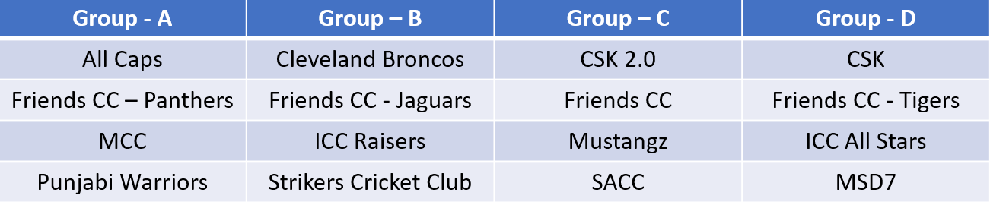
Each team will play with remaining three teams in their group
After all the league games complete, we will number the teams from 1 to 16 based on the points and NRR.
Top 12 will be qualified for next stage (not group toppers but top 12 ranked teams from 16 teams).
Top 4 out of qualified 12 teams will directly play quarters and 5 to 12 rankings will play pre quarters as mentioned below.

- Pre-Quarter Finals (Eliminators)

Team | Status
Rank 1 | Qualified to QF
Rank 2 | Qualified to QF
Rank 3 | Qualified to QF
Rank 4 | Qualified to QF

Game | Team |  | Team
PQF # 1 | Rank 5 | vs. | Rank 12
PQF # 2 | Rank 6 | vs. | Rank 11
PQF # 3 | Rank 7 | vs. | Rank 10
PQF # 4 | Rank 8 | vs | Rank 9

- Quarter Finals

Game | Team |  | Team
QF # 1 | Rank 1 | vs. | Winner of PQF #4 (R8/R9)
QF # 2 | Rank 2 | vs. | Winner of PQF #3(R7/R10)
QF # 3 | Rank 3 | vs. | Winner of PQF #2(R6/R11)
QF # 4 | Rank 4 | vs | Winner of PQF #1(R5/R12)

- Semi Finals
Game | Team |  | Team
SF # 1 | Winner of QF #1 | vs. | Winner of QF #4
SF # 2 | Winner of QF # 2 | vs. | Winner of QF # 3

- Finals
Game | Team |  | Team
Championship | SF # 1 | vs. | SF # 2

