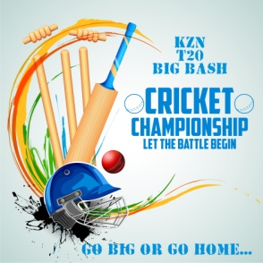
KZN T20 BIG BASH
To whom it may concern

We are a T20 league based in Durban and would like to give you the opportunity to sponsor one of our sides. We try to promote a healthy mix of exercise and family time in what we do. We are encouraging youngsters to participate in this competition which is needed to motivate the youth of today.
Running a team consists of 8 committed players at a cost of R80 per game which includes a new ball, umpires, on field cameras, live scoring and stats and a whole lot of fun and family time. Our current league will run for 12 weeks which will result in 12 games excluding playoffs and finals. This amounts to a total of R7680 for the season. The season starts on the 30 September until the 20th January 2018. Any assistance you could give any of our teams would be greatly appreciated.
The Sponsors
The sponsors are expected to provide their financial contribution to the team. In return of this, all the members of the team sponsored can wear t-shirts or uniforms that have sponsor's logo and title on it. These uniforms can be arranged through us or on your own and will be used during the season and events where our players will participate...ie fundraising events, golf day etc etc. We would be happy to display banners during our games. All that would be required is to liaise with the team you are sponsoring and we’ll arrange the rest. Branding, signage, advertising can be arranged at additional costs. Should you be interested please do not hesitate to contact us. We have a facebook page which you can peruse at your will by clicking on the facebook icon below.
Your kind assistance will be greatly appreciated. .
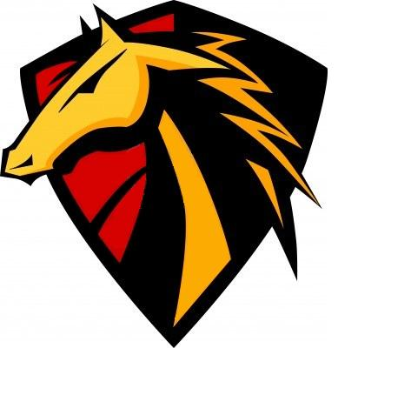

Thank you for considering our proposal of sponsorship

