Cricclubs – How to Merge Duplicate Player Profile
Step by Step (Self Guided process for NTCA Members)

- Go to NTCA Cricclubs (http://www.cricclubs.com/ntca)
- Login to your primary profile
- Go to Players Player Search
- Enter Player name. Find the duplicate player profile and go to player profile page. Right under player name if you see – Is this you? Claim your profile Click on it.
- On the pop up window, proceed to claim profile. (Screenshot 1)
- Profile Claim request is sent to League admins for approval. (League admins approve claims on a periodic basis (not every day ), feel free to contact admin (all EC members are admins) (Screenshot 2 – for cricclubs admin)
- Once the Profile claim is approved, you should receive email notification depending on your preferences.
- In the cricclubs website you will see Merge Profiles page appear (if required re-login).
- Click Merge button, you will receive an email with verification code in the primary email associated to this profile. (Screenshot 3)
- Enter the verification code and submit to complete Profile Merge. (Screenshot 4)

Some Screenshots below:
Screenshot 1
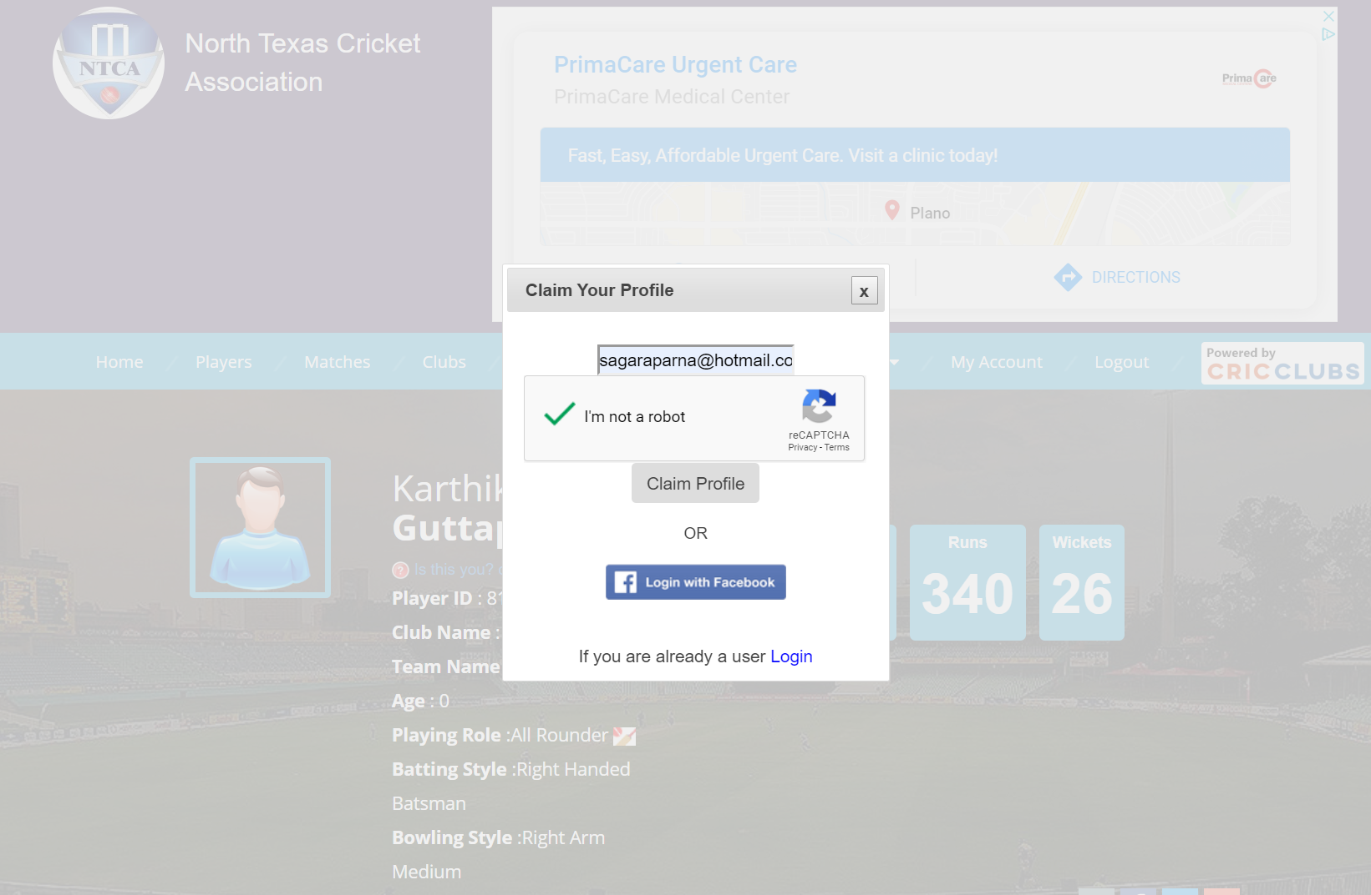
Screenshot 2 (LEAGUE Admins will approve all claims)
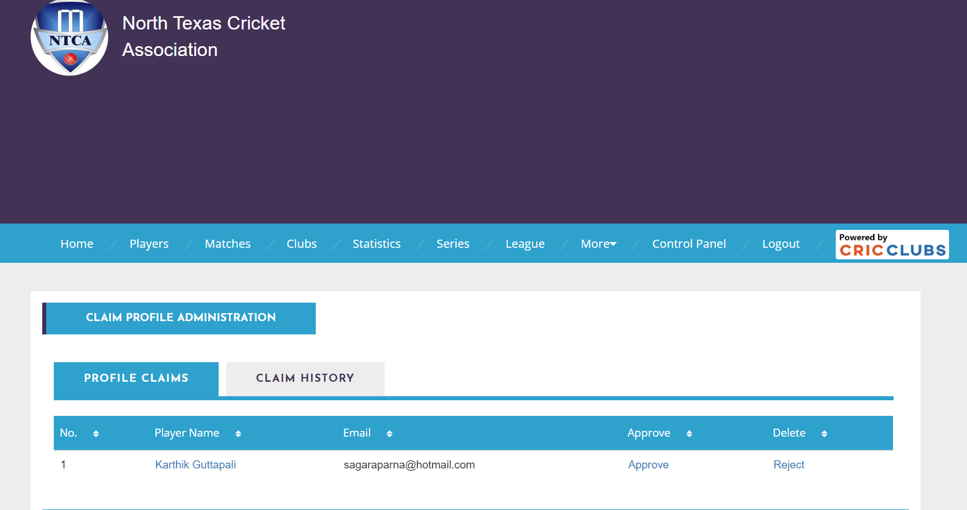

Screenshot 3: (Merge page shows up after login once admin approved profile claim)
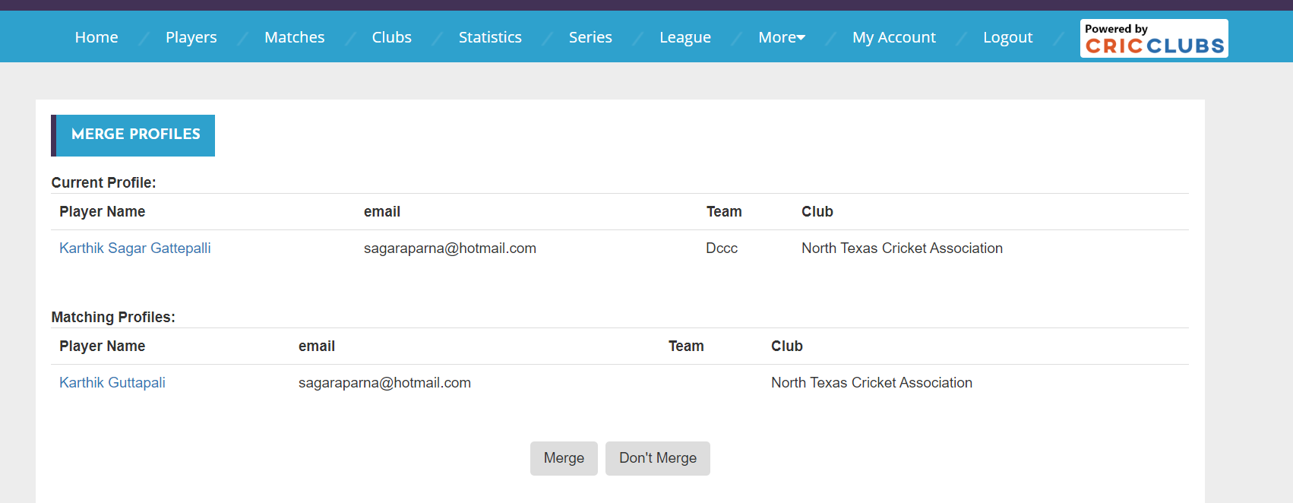

Screenshot 4: (Enter Verification code to finish Merge)
