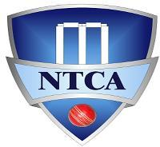

2021 DIVSIONAL GENERAL MEETING
Saturday 2/13/2020 @ 10.30AM
AGENDA
- 2021 Registration
  - NTCA Primary League
  - NTCA T20 league
  - NTCA Youth League
NTCA Registration is closed. We have 45 teams in Primary League and 23 teams in T20 League. Season will commence on March 6th.
NTCA Youth League schedule will be published separately.
*** NOTE: Teams with either home ground available Saturday or teams with no home ground will play most of their games on Saturday (B-division) ***

- Umpiring Panel (Why, How, Expectations and timelines)
Still in progress

- Umpiring certification – Saturday, Feb 27 at 9.30 AM

Expected of 5 hour session starting at 9AM, session will be held through zoom. Google classroom will be used for organizing the session and online exam and results will be known instantly. We request all non-certified players in clubs are notified and have to attend umpiring seminar – There are strict rules for paid umpiring going forward. If they have a certification from other leagues, send list to Anwer/EC to get clearance.
*** NOTE: Google Form based registration will be shared by end of day 02/24/21 – Mandatory Gmail ID required for registration.
Registration will close EOD 02/26/21 ***

- 2021 Calendar
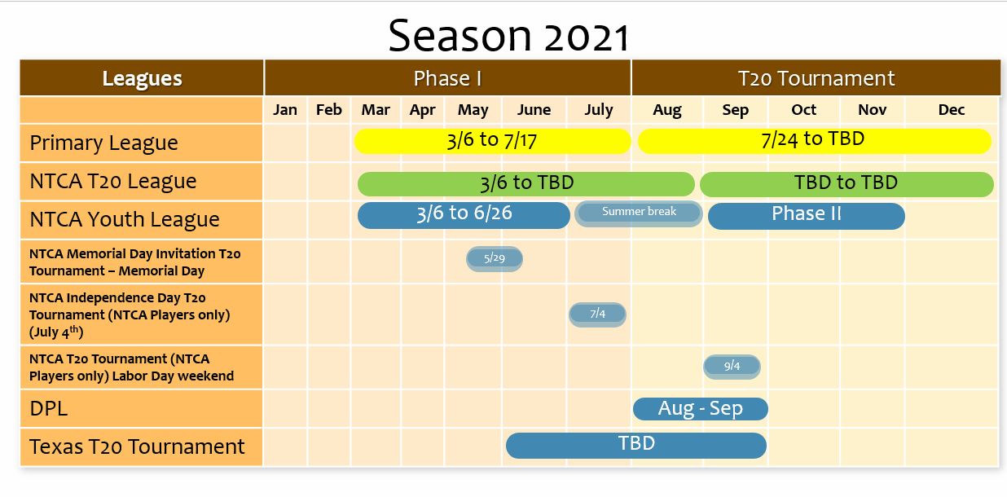
- NTCA Leagues
  - Youth League
  - NTCA Primary League
    - Premier, A and B division (45/40/40 overs)
      - Ranking will be locked at the end of league phase, promotion and relegation will happen based on league rankings.
      - Playoffs for all the divisions
        - Premier and B division will have top 4 teams in playoffs.
        - A division will have top 3 teams in playoffs.
*** NOTE: Players playing in Playoff’s should have played at least 50% of games played in League phase ***
      - Playing format for playoffs will be published
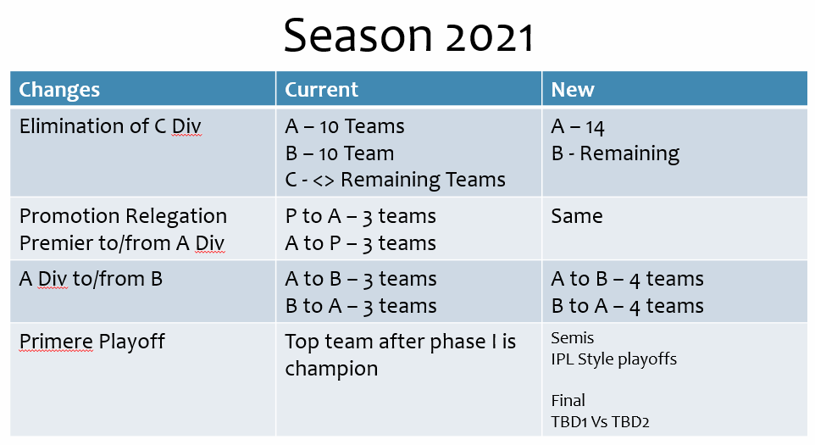

    - NTCA Primary T20 (Legacy T20).
This tournament will be named after former NTCA players who are no more with us.
  - NTCA T20 League
    - 2021 – All teams play for ranking
      - 2022 – Teams will be split into divisions
      - Club based format
    - T20 tournament for the teams playing the T20 league only
    - New team entry will be allowed for the T20 tournament
    - Registration fee will be 600$ (teams with home ground) and 1000$ for teams without home grounds
- NTCA Seniors and Youth player pool
  - The NTCA selection committee will select a pool of Senior and U19 players, who will be representing the NTCA teams for regional tournaments and or selections.
- NTCA T20 Tournaments
  - Memorial Day – NTCA Invitational T20 Tournament
    - Team comprising of Lovkesh Kalia as Tournament Director along with many others to organize this tournament. We have secured 5-6 teams already.
  - July 4th weekend – NTCA Independence Day tournament – a low fee tournament which will be only for the NTCA based teams. Venue and logistics to be announced.
  - DPL – DPL will be played during August – September, details will be announced accordingly.
  - Labor Day – NTCA tournament – for now this tournament will be NTCA based only, details to follow.

- Logistics
  - Umpiring seminar – Online with online test
  - Max 2 paid umpiring per team per tournament
  - Cricclubs being migrated to paid version, enhancements will be done to remove ads.
  - Additional section will be added for Youth league.

- NTCA Social media
  - All the ads will be removed going forward
  - Vendors to reach out to NTCA EC for pricing

- Few By-laws updates
  - Mandatory whites/color cloths – penalties for non-compliance
    - Make sure to order some additional cloths for players joining in mid-season. No exceptions.
  - NTCA Primary T20 (Legacy T20) and T20 League T20
  - Umpiring
    - From 2021 onwards following rules will apply for paid umpiring
      - A team gets max of 2 requests for paid umpiring per tournament or league games.
      - Paid umpires MUST be certified.
      - A player who wishes to be paid umpire MUST register with NTCA umpiring committee and certification verification will be done.
      - Umpire should be active player of a club or team. A non-playing member of a club, unless he has played NTCA games in past, CANNOT be considered as umpire from a particular club. (Details and clauses will be added to by-laws)
      - Captains MUST send paid umpire details to the OC, copying the playing team captains or representatives. Penalty will be imposed for no communication and or non-compliance.
      - If Operations committee finds out incorrect information being provided by teams/clubs – penalty (monetary and or point deduction or playoff disqualification could be imposed)

- Covid regulations
  - Covid regulations to be published separately.

- USA Cricket update
  - Mandatory player registration email has been sent out. All the club reps are required to send the registration details

