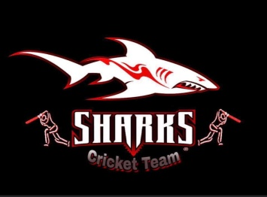
Rules & Regulations
Game Rules
- 1st Group stage match will be 8 over each innings. Semifinals and Final will be 10 over.
- Teams will be divided into 2 groups and each team will play 2 games. Top Two teams from each group will be qualified and will play Semi Finals and then Final.
- Each bowler can bowl 2 over in 1st stage, in Semifinals and Final only 1 bowler can bowl 3 over and rest 2 over.
- There will be 2 over Power play in 1st stage and 3 over in Semifinals and Final.
- There will be bye runs but no leg byes will be counted. (If a batsman tries to take runs when it's a leg bye there will be no run out or runs.)
- No LBW.
- Runners will be allowed only the out batsman or 12th man.
- Any staff of the fielding team put in the field touched by the bowl during the game will automatically add 5 runs to the batting team.
- Any kind of no ball is a free hit.
- 2 runs counted in the back when the ball goes dropping and 4 run if go directly.
- 2 players allowed during power play, otherwise 5 players allowed outside the circle (no ball can be called by the umpire).
- No warnings will be given by the umpires for the field restriction. Umpires can call it a no Ball without warnings.
- 5 players allowed in leg side(no ball can be called by the umpire).
- DLS method will be counted during rain or any unconditional weather.
- If game cancel during weather, point will be shared, or can play in the empty spot upon discussion
- 5 minutes late will deduct 1 over from the late team.30 mins automatically counted as a walkover.
- 6 minutes time to complete 1 over, late over will give the batting team 5 extra runs as a penalty for the bowling team.
- Each 5 minutes late start for weather or any other things will deduct 1 over from both teams.
- Only Players who will be playing the 1st stage game will be allowed to play Semifinals and Final. No new players can be added to Semifinals and Final.

Discipline Rules
- Organizers will do the Umpiring for all the games except their own games. Organizer will decide the Umpires for those games.
- Umpire decision is final, no argument will be allowed with umpire, if anything wrong with Umpire, Organizers will decide the Outcome.
- Main Umpire can change a decision anytime by discussing with the Leg Umpire.
- Mask is mandatory. No players will be allowed without mask, bowler can take off mask during bowling.
- All teams will be responsible for cleanliness.
- Slight sledging allowed, but no serious arguments, curse or physical abuse will be considered.
- If we have any situation in the game with anything, only the Captains are allowed to speak on behalf of the team with the Umpires or Organizers.
- No smoking or alcoholic beverage allowed except sanitizer during game in the field.
- Respecting the opponent team is mandatory.
Fees

150/= is the tournament fee.

Prizes

- Winning team will get $300 and Runners Up will get $200 as prize money.
- Each match has Man of the Match Trophy, also MVP, Runners Up, Best Bowler and Best Batsman Trophy.
- Anything missing in this rulebook will follow the ICC format.
Others

- Water will be provided by the committee.

