**TDF, Canada Sports Club presents 4th Prof. Jayashanker Memorial Cricket Tournament**

**Tournament: Rules, Registration and Procedure**

**When: JULY 13th, 14th and July 20th, 2019.**

Knockout matches 9:30AM to 6:00PM

**Venue:**130 Overlea Blvd, North York, ON M3C 1B2

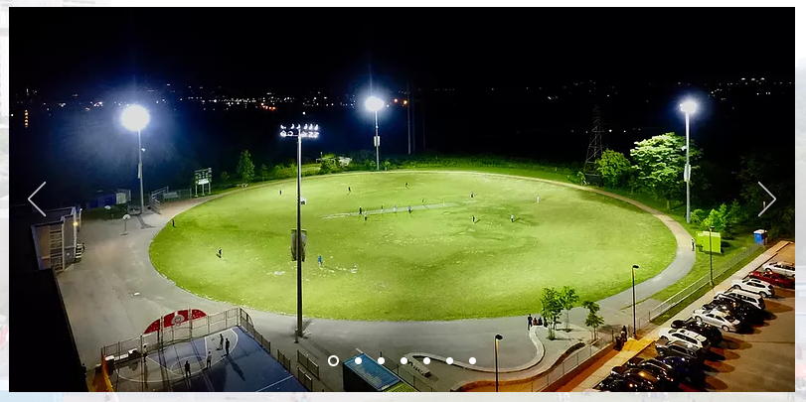

**All the Schedules has been updated in the Cricclubs.com schedules tab.**

**Rules Document:**

Every team can register a maximum of 15 players, and must have a minimum of 11 players, four extra players are recommended.

**Tournament Rules:**

**We expect the team members to have fun and a sportive game**

The following rules are to be followed. Rules are subjected to change

1. During the tournament all participants are expected to behave professionally and should avoid abusive language/gestures/question Umpires decisions. All participants must remember to treat other players with respect.
2. Cursing is considered as abusive, hateful, or malignant language or behavior.
3. Captain is responsible for circulating information to all the teammates.
4. Every teams **MUST** arrive at least half an hour early then scheduled time.
5. Every player should sign waiver form and submit it to organization team.
6. TDF CANADA is not accountable for any injuries during games.
7. In any case, if a team failed to report on time that team will be Forfeit and opponent team will be declared as winners.
8. Knockout Innings consist 14 overs and bowlers can bowl a maximum of 3 overs.
9. Semis Innings consist 15 overs and one bowler can bowl maximum of 4 overs.
10. Finals innings consist of 16 overs and two bowlers can bowl maximum of 4 overs.
11. The twelfth man is not allowed to bowl, bat, wicket keep or captain the team. His sole duty is to act as a substitute fielder.
12. First two overs will be mandatory Batting powerplay only two players allowed to field outside 30-yards circle.
13. From overs 3-12 in knockouts a maximum of 4 fielders are allowed outside 30-yards circle.
14. Last two overs will be bowling power play a maximum of 5 fielders are allowed outside 30-yards circle.
15. There are only five fielders allowed on the leg-side of the field. If the right arm bowler bowls from around the wicket, he becomes the six fielder which infringes the leg-side no ball rule and will be declared No Ball. But this law is applicable to only leg-side, you can put all the fielders on off-side.
16. Byes, Leg byes, Overthrows, Wide and all No balls are applicable in this tournament.
17. LBW is not applicable and there is No Free hit for a No Ball.
18. If any player is deemed to be violent, ill-cooperative, or dangerous to anyonearound him, he will be removed, and possibly a police report will be filed.
19. In case of a tie in a match, Win well be decided by super over.
20. All International Cricket Rule of Super over will be applicable in case of Super over.
21. During bowling your arm must be completely straight, zero degrees of bending is allowed, any noticeable bending of the arm will result in being called a 'no ball'. In case of a bowler bowling three illegal delivers(chucking) result in loss of bowling privilege.
22. If a bowler bowls more than 2 waste high, No-Balls will result in losing bowling privileges.
23. Playing Eleven list must be presented at the time of the coin toss.
24. Umpires reserve every right to declare a no ball with or without warning, if any bowler delivers under arm or throw ball.
25. Teams are advised to avoid any unnecessary delay before or during the game to maintain our time schedule.
26. Organizing committee will reserve full authority to intervene in such case off field and umpires will have full authority to intervene in field.
27. Umpire's decisions will be final throughout the tournament. Any sort of misconducts by any players will result in direct suspension.
28. Organizers reserve the right to change the venue, date time.
29. A team must be ready to play two matches in a day, if required.
30. Number of over’s in each innings will be reduced depending on the weather conditions.
31. In case of “Mankad” player should be given one warning, before giving him out.
32. Price money for Winning team is $750 Along with Trophy.
33. Price money for Runner-up is $350.
34. Man-of- the-series and Man of the match for finals will be awarded.

**Event sponsor:**

**Jitendhar Reddy Garlapati**

**ROYAL LePAGE | United Realty**

[www.gtahomescondos.ca](http://www.gtahomescondos.ca/)

+ 1 (647) 838-0780

-- -- -- -- -- -- -- -- -- -- -- -- -- -- -- -- -- -- -- -- -- -- -- -- -- -- -- -- -- -- -- -- -- -- -- -- -- -- -- -- -- -- --- -- -- -- -- -- -- -- -- -- -- -- - [www.tdfcanada.org](http://www.tdfcanada.org) [|info@tdfcanada.org](mailto:|info@tdfcanada.org) | fb.com/tdfcanada.org | 1-855- 838-4833 (4TDF)

Telangana Development Forum, Canada (TDF, Canada)