CricClubs Live Scoring
Help Document
(v 1.0 – Beta)

Table of Contents:

Installing / Accessing the Live Scoring App……………………………………………. 3
For Android Devices
For iOS Devices (iPhone / iPad)
For Windows Devices
For any PC / Mac
High-level Flows……………………………………………………………………………………. 4
Setup of Live Scoring
Perform Live Scoring
Detailed Instructions…………………………………………………………………………….. 5
Setup of Live Scoring
Perform Live Scoring
Contact Us…………………………………………………………………………………………… 16

Installing / Accessing the Live Scoring App:
Live scoring app can be accessed from within the CricClubs Mobile App. Below are the instructions for installing / accessing the CricClubs mobile app.
For Android Devices:
- Launch Google Play Store on android device
- Search for app – CricClubs
  - Locate the app with name “CricClubs Mobile”
- Install the CricClubs Mobile app
  - A new app icon will appear in the app listing
- Go to the apps listing and launch CricClubs using the icon
For iOS Devices (iPhone / iPad):
- Launch App store on iOS device
- Search for app – cricclubs and the app will be displayed as shown below.
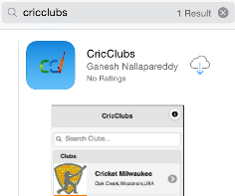
- Start downloading the app
- Once the download is completed, the app can be launched from the phone.
For Windows Devices:
- Go to Store on windows phone
- Search for app - CricClubs
- Download and install
For any PC or MAC:
- Launch internet browser
- Open web address http://cricclubs.com/smartapp

As a pre-requisite to live scoring, CricClubs Mobile application need to be installed / accessed. Live scoring in CricClubs of any match has two simple steps. The instructions for live scoring are explained below via a high-level flow diagram followed by detailed instructions. The app and the user interface are pretty self-explanatory and most users should be able to navigate through without having to reference the instructions.

High-level Flows:

Step 1: Setup of Live Scoring (by Admin or the playing team Captain)

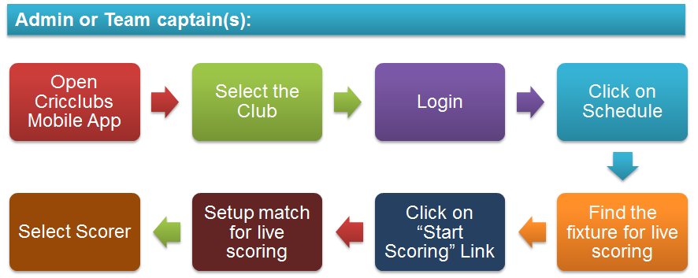

Step 2: Perform live scoring (by scorer logging into the app)
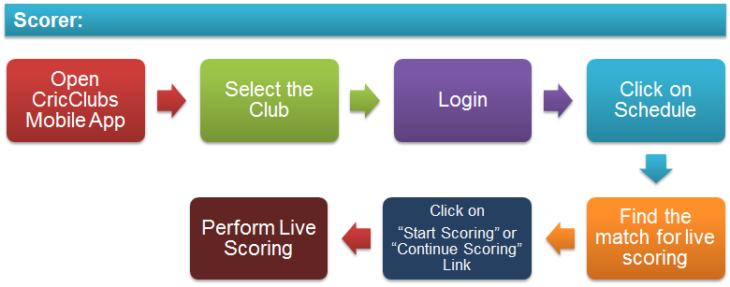

Detailed Instructions:
Step 1: Setup Live Scoring
This step needs to be done on the day of the match or just after the toss is done for the match. Admins and the team captains play a critical role in setting up live scoring. No other players can setup matches for live scoring. Live scoring can be setup by Admins or playing teams captains by logging into the CricClubs mobile app using the Login menu with in the club home page. All scheduled matches can be accessed via “Schedule” menu in the club home page of the mobile application.
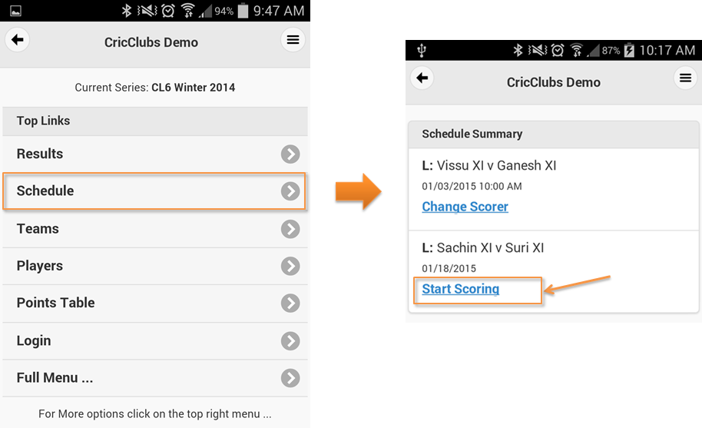
When admin or match captain logs in, matches that are ready for live scoring will have a “Start Scoring” link.
The live scoring setup screen requires the following information to be completed:
- The playing 11 or less from “Team 1”. If all 11 players are not known, simply select the players that are known to play. The number of players selected per team can be tracked at the bottom of the screen.
- Captain for “Team 1”
- The playing 11 or less for “Team 2”. If all 11 players are not known, simply select the players that are known to play. The number of players selected per team can be tracked at the bottom of the screen.
- Captain for “Team 2”
- The team that won the toss
- The team that is batting first
- Maximum overs per innings
- Scorer for the match
Since the players as well as the toss winner need to be identified, this step cannot be performed until day of the match.
Player selection for “Team 1”:  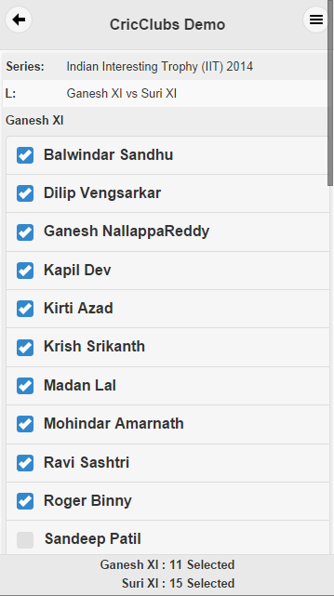 | Player selection for “Team 2”:  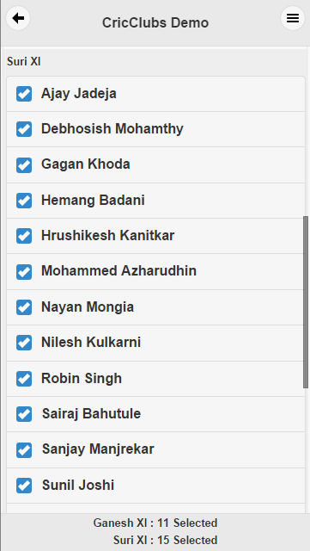 | Toss and Scorer Details:  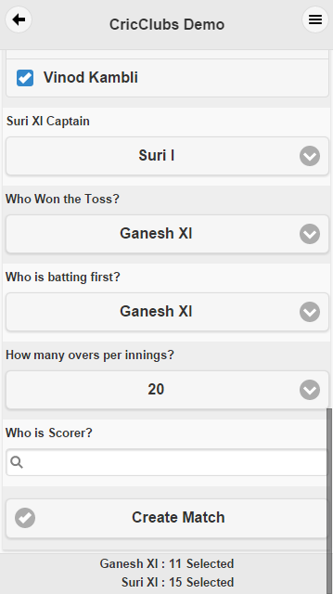
Once all the information is entered, a match is created in live scoring mode and listed as “Live” on the Club Home Page as shown below.
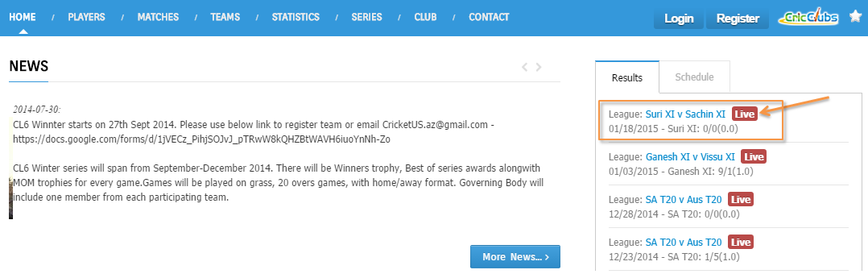
Step 2: Perform Live Scoring
Login as Scorer and Select Continue Scoring. Match live scoring screen page will appear for Scorer inputs.
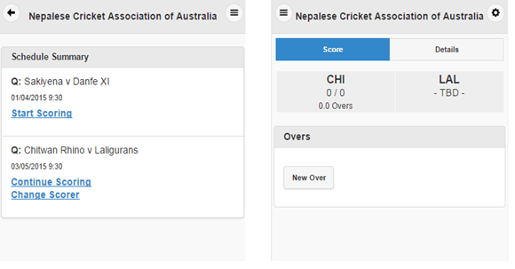

Select New Over to start scoring. Select Batsman, Runner and Bowler from drop down lists which appears once you click on each button - Set Batsman, Set Runner and Set Bowler.
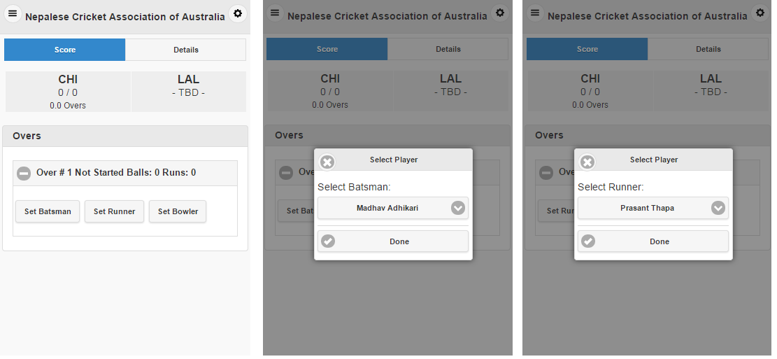

To record any ball, Scorer needs to click “New Ball” Button. This will open a new window with scoring options and details indicating Batsman, Bowler and non-striker for ball being scored. Scorer needs to score as appropriate
- For Runs select 0,1,2,3,4(ran 4), 5, 6(ran 6), 7, Four!(Boundary) and Six!(Boundary)
- Extras if applicable Select Wide, No Ball, Bye, LegBye
- For legal(non-extra) balls Extras selection would be None(default)
- For Extras any runs scored extra needs to be selected. For wide/Noball and no run scored by batsman Runs selection would be 0. This will add just one run to team score. For wide/Noball where batsman score additional runs those needs to be selected in Runs. Team total will be increased by Extras(1 run) plus runs scored by batsman
- After selection Click Next to proceed with details entered.
- In specific cases (wicket of previous ball) Scorer needs verify correct batsman is on strike for ball being recorded. Scorer can swap batsman on strike using button .

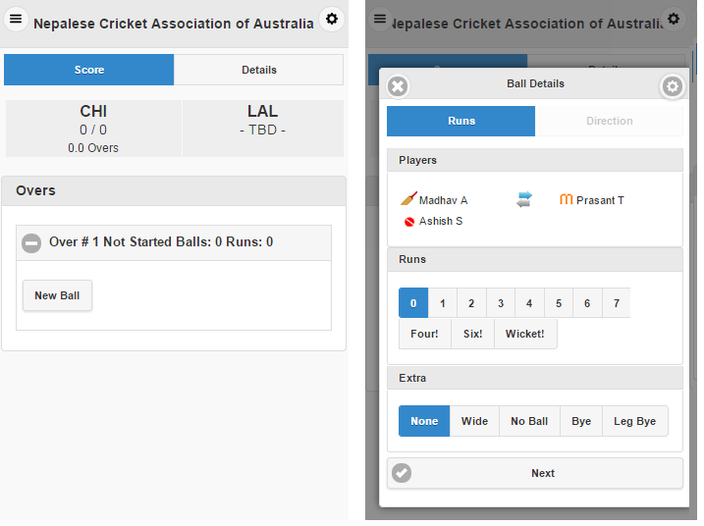

When there are any runs scored on a given ball, App will display Ground image to record ball’s direction. Scorer needs to click on Ground image to record where ball was played. In current example ball was played towards long on.
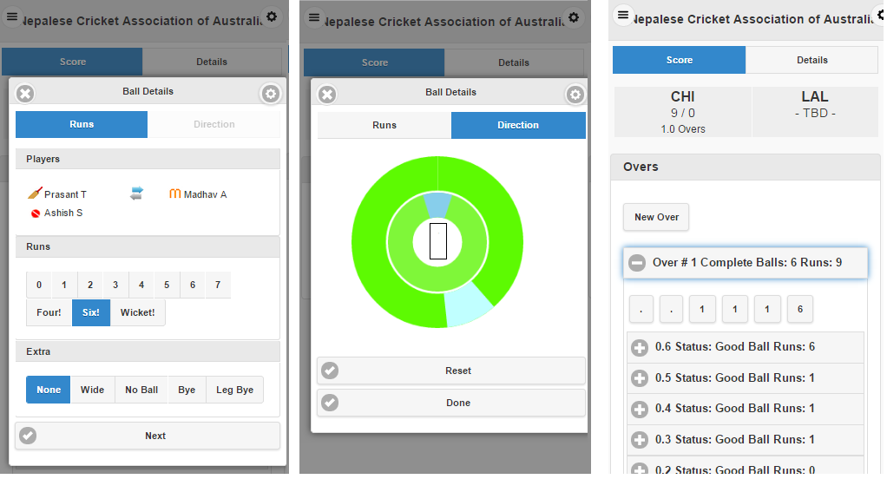

On Club homepage in Live Scoring - Ball By Ball tab, this would appear as below.
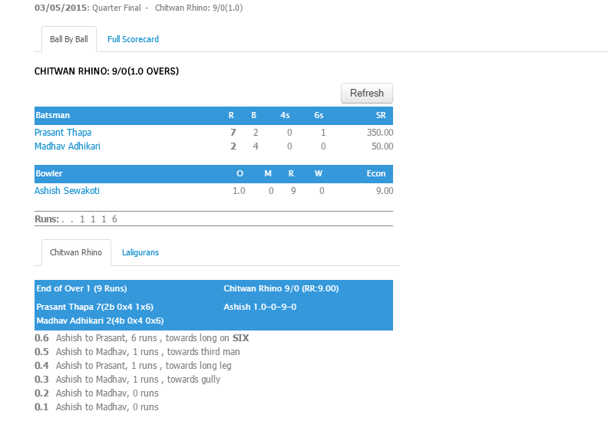

When there is wicket on legal (non-extra) ball, Scorer would select Wicket Button and Extras None for legal (non-extra) ball and app would Wicket details Screen with all wicket types.
When there is wicket on Extra ball (Wide, Noball, Bye, LegBye) Scorer would select Wicket Button and Extras as per ball and app would Wicket details Screen with only allowed wicket types.
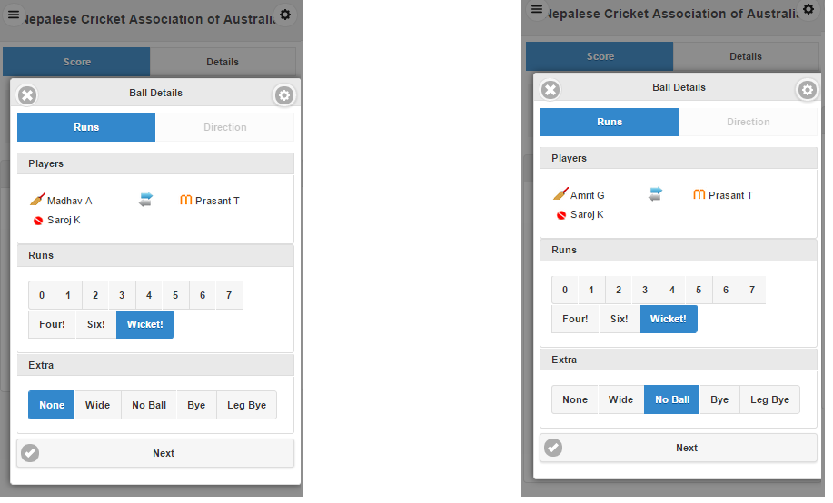
Wicket Detail window provides all allowed types of out types for category of ball Legal or Extras from all possible out types(Caught, Run out, Bowled, Stumped, LBW, Hit wicket). Based on Out type selection Player 1/Player 2 (Fielders) options are displayed. In case of Bowled/LBW/HitWicket, no Player 1 option. In case of Caught/Stumped, Player 1 option is displayed to select Fielder. In case of Run Out, Player 1 and Player 2 (Fielders) options are displayed.
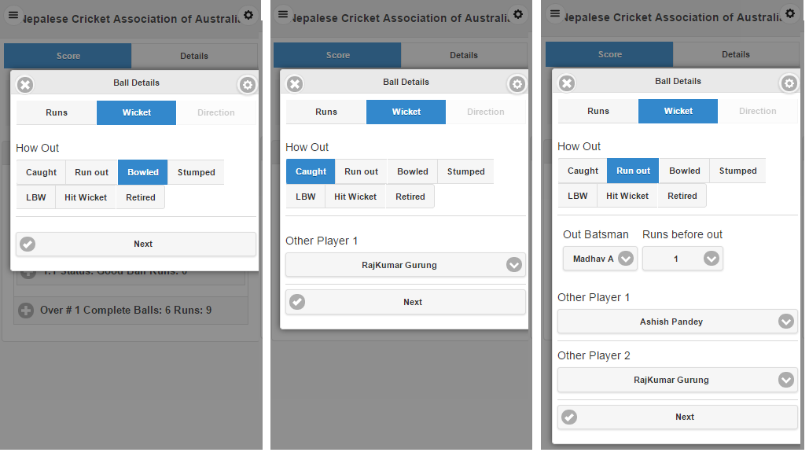

On Club homepage in Live Scoring - Ball By Ball ta, this would appear as below.
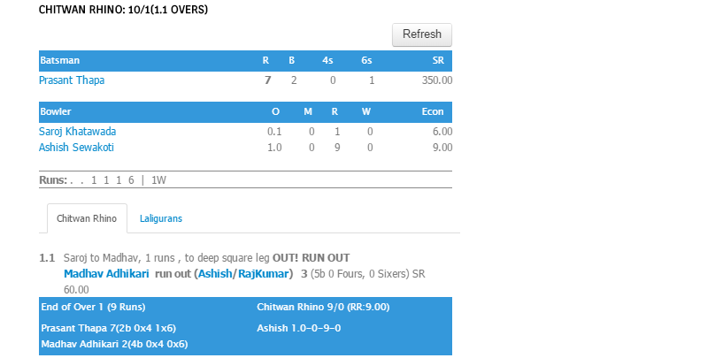

Use Set batsman to Select Next Batsman coming in. To ensure correct batsman is on strike for next ball in case of Catches/RunOuts where batsman has crossed, please click on swap button available between two batsman names.
If details entered for previous ball are incorrect, select ball by clicking on the ball box. Then enter correct details and click Next. If Scorer intends to delete the ball and reenter, then click on top right corner button of Ball details window and select delete ball. Ball can be reentered using New Ball button with correct information.

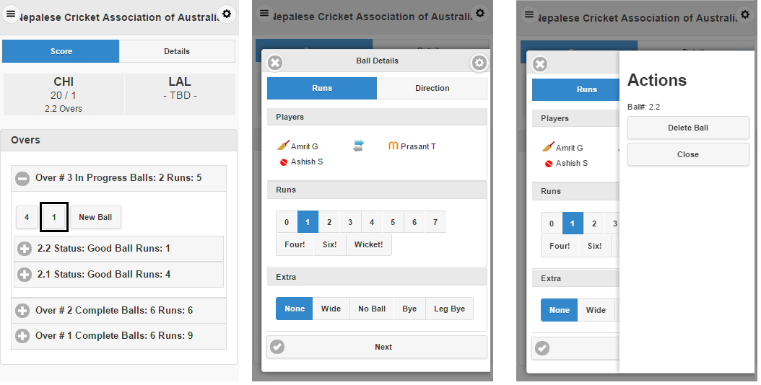

After completion of first innings (10 wickets or completion of overs) click Button Start Second Innings for second innings.
Scoring app has top right corner button with three options.
- Add Player(s) to playing 11 which were not selected during match creation
- Change Bowler to record new bowler in between over if new bowler completes over as existing bowler fails to complete over on account of injury or something else
- End Match to complete match in between for any reason if game fails to proceed.

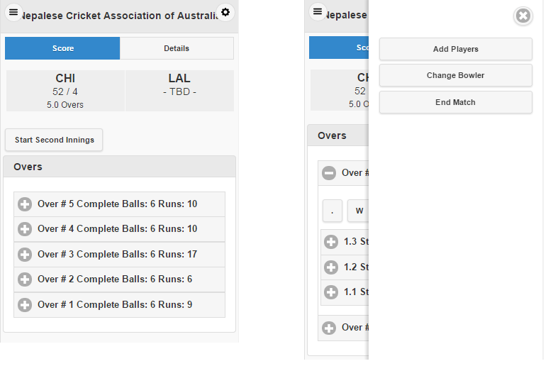

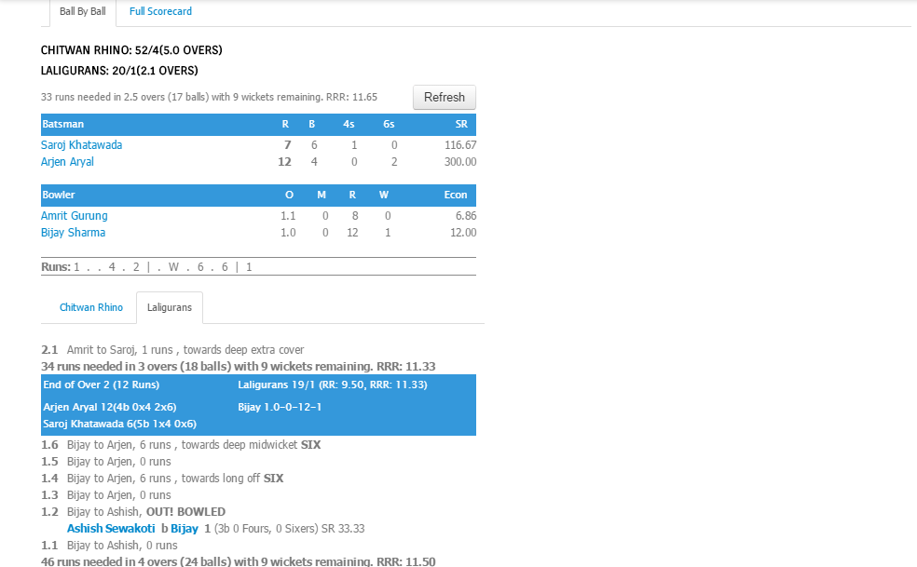
After completion of Second innings (10 wickets or completion of overs or Target achieved) click Button to Publish Scorecard.
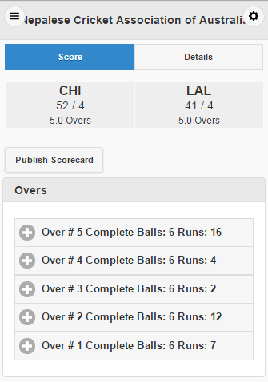
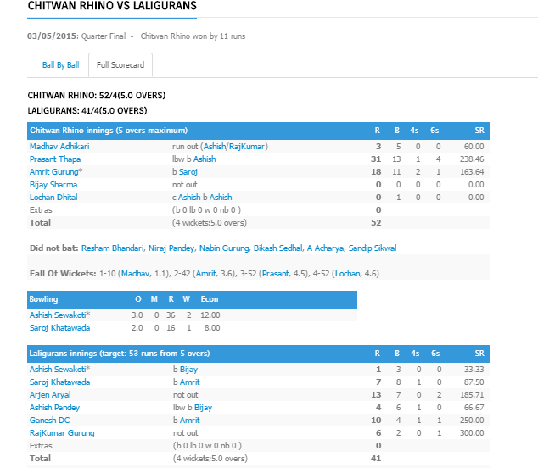

Contact Us:
For any questions/Suggestions, please contact below
Website: www.cricclubs.com
Email: support@cricclubs.com
Phone: (262) 724-6010

