Winners Trophy 2020 | 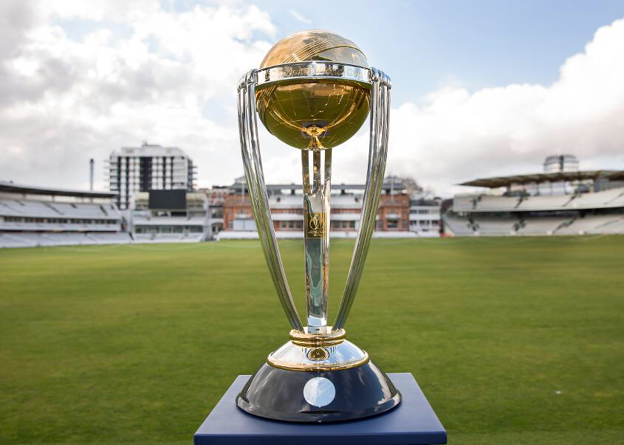
  - Season 1 – Rulebook 2020

Definitions
Wide , No ball and Dead Ball are all same as we see in International cricket. We will have crease markings for easy identification to umpires.
No ball:
- When a blower don’t specify the guard or his bowling action to umpire. At least at the beginning of bowling and while sudden change of bowling action, bowler should alert umpire. This is the thumb rule behind it.
- When a bowler over cross the crease while bowling
- When a ball goes on and beyond waist height of batsman without bounce
- When identified more number of players than expected inside the inner circle or anything against field restrictions
- When a ball goes on and beyond height of batsman shoulder in Batsman’s Standing position. “NO” warning for first bounce. If it goes above shoulder with a bounce, it should be called as a No Ball.
Umpire should declare the No ball immediately after bowling action completes. No ball declared after the ball is dead is not acceptable. Batsman is NOT OUT in any other circumstances other than “Runout” for a No-ball.
Wide:
A wide ball will be called when the batsman, playing a normal stroke, is unable to reach the ball. Let’s keep the rule of wide when ball passes “ON” or “after the wide crease” in Batsman’s regular standing position.
When the batsman moves to his leg side or offside then the decision will be taken by Umpire. And that decision is final. No arguments on that.
Dead Ball:
Ball pitching ground more than once before the batsman crease.
All other Dead ball rules as per ICC rules.
BYES:
- NO LEG BYES N NO RUN OUTS IN CASE OF LEG BYES
- We HAVE RUN OUTS WHILE BYES AS WE HAVE ALL BYES EXCEPT LEG BYES

DEFINITION OF BOUNDARIES :
UMPIRES WILL EXPLAIN PLAYERS ON BOUNDARIES N FIELD RESTRICTIONS
POWER PLAY:
- 1st 2 overs of innings are mandatory power play. ONLY 3 outside inner circle.
- One bowling power play and one batting power play as per team decision. Captain/batsman should announce
To umpire before commencement

Mankadian rule :
- Only 1 warning to entire team. Bails should get off to claim OUT. Incase of no bails , need to get stumps alter from normal position.
Max Overs per Blower Rule:
Max 4 overs for only for 1 bowler. Remaining can be as per captain’s decision
TOTAL OVERS FOR INNINGS : T16 format. 16 overs.
Breaks:
After completion of 8 overs in each innings for 6 mins.
15 mins Break after 1st innings.
Break can be voided in case of running out of time for the second innings or match with both captains & umpires decision.
New Ball replacement Incase of lost:
New Ball will be provided only Incase of ball lost before completion of 6 overs.
Even if it happens at 5.5 Ball has to be given.
Declaration of players:
All 11 and 1 sub (only for field) SHOULD be announced before commencement of match and Physically be present in ground before 4th over completion.
Match call off:
In case of adverse weather condition and sudden obstacles on ground, Umpire should declare call off the match by explaining situation to both captains. Rematch will be conducted at later stage by committee.
Minimum number of players to start the match on time:
At least 7 players should be in ground to start the match ON time. NO DELAY is entertained. Umpires can take decision on awarding points to opponent of team which had NO SHOW.
Field Set up and introductions:
Both captains should be present at least 30 mins before the actual start time of the match. Get introduced to umpires and help them setting field.
Super over:
In case of tie, we will implement super over. Incase of tie even after super over, winner of the match will be declared on basis of wickets fallen. The Team has lost Lowest wickets will be declared as winner.
By runner:
By runner will be allowed ONLY from 12 Incase
If Batsman is injured in the ground while batting and in bad situation to run, Umpire should decide and allow By-runner upon agreement on both captains.
Substitute:
As always, we allow making use of one fielder to substitute for field at any point of time. The one whom he is substituting should be present on field for at least 3 overs.

Concerns:
If anybody wanted to raise concerns, they should report it to Disciplinary Committee. They should reach their captain and he should report to Disciplinary committee over phone or Email. Phone numbers and emails will be shared with Captains. In case of on field decisions Umpires can reach out to DC for any decisions. DC will let the Umpires know what the rule is and Umpire will have complete responsibility to take decision, it is NOT DC.
Walk Overs:
Winners Trophy strictly does not encourage the walkovers. If the team would like to give walk over to opposite team, they should give proper explanation to DC & Committee. Upon the explanation, Committee will run the voting for acceptance of Walkover. If committee feels it as a valid reason then points will be given to opposition. If not the team who proposes the walkover will be penalized.

