**Great Lakes Cricket Tournament Fall T20 FORMAT – 2019**

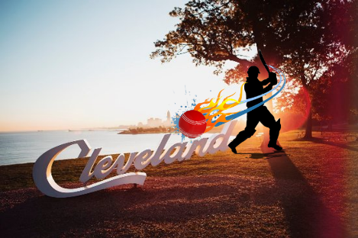

* Total 12 teams registered for GLCT T20 2019 tournament.

1. Cleveland Blazers
2. Cleveland Krushers
3. Cleveland United
4. CRC Red
5. Cuyahoga
6. Erie United
7. Erie All Star
8. Lions
9. OCCC
10. Cleveland Dynamites (new)
11. CRC Blue (new)
12. Kent Black Squirrels (new)

**12 Teams Group Format:**

|  |  |
| --- | --- |
| **Group A** | **Group B** |
| CCC United | CRC RED |
| OCCC | CUCC |
| LIONS | CCC BLAZERS |
| KRUSHERS | ERIE STAR |
| ERIE UNITED | CCC DYNAMITES |
| CRC BLUE | KENT BLACK SQUIRRELS |

* 12 teams to be divided in to two groups (Group A & Group B) of six each.
  + Rankings will be based on the 2018 MCT Fall T20 results (for 2019 year only)
  + Assuming same 12 teams will partake in 2020. All rankings will be based on GLCT 2019 Fall T20 results.
  + Any new team joining the GLCT T20 Tournament will start from the bottom of the rankings.
* Scheduling Committee to keep both Groups A & B to be in equal strength. (Any adjustment required (to any group) to avoid one sided scenario will be approved by the Board).

**League Stage Format**:

* All teams will play 5 games each in their group.
  + Note: SC to ensure 2 games played per day should be the 1st criteria.
* No cross games will be allowed between groups.
* For 2019 year, all teams must play at least one game with Hammer ball. Teams are allowed to choose the game with mutual understanding of opponent team. Game must be conducted with Hammer Ball by both teams. TOC will make the call on which game to use the Hammer ball, if any teams are not in agreement or a team have not used Hammer ball by their 3rd game.

**Playoffs Stage Format**:

* Top 4 teams from each group will contest in the playoffs, with quarter-final, semi-final, and final. The higher ranked team will receive a home field advantage only for the quarter-final. Semi-finals and finals will be at neutral venues as decided by the Board in consultation with SC.
* All 8 qualified teams from Group A & B will be ranked 1-8 as per below.
  + Points
  + NRR (4 decimal points)
  + Head to Head
  + Coin Toss
* Quarter Finals: Oct 5th
  + Quarter Finals 1: Rank 1 vs Rank 8
  + Quarter Finals 2: Rank 2 vs Rank 7
  + Quarter Finals 3: Rank 3 vs Rank 6
  + Quarter Finals 4: Rank 4 vs Rank 5
* Semi Finals: Oct 12th
  + Semi Finals 1: Winner of Quarter Finals 1 vs Winner of Quarter Finals 4
  + Semi Finals 2: Winner of Quarter Finals 2 vs Winner of Quarter Finals 3
* Finals: Oct 12th
  + Winner of Semi Finals 1 vs Winner of Semi Finals 2

**VENUES FOR PLAYOFFS**

* QF: Would be at home for higher seed based on home ground availability.
  + Note 1) If two or more teams are sharing a home ground, the higher ranking team will get to play their shared home ground and the lower ranking team will have to play on the next available ground. For ex: Cuyahoga (ranked #2 in QF) & OCCC (ranked #4 in QF), since both teams are sharing Warrensville ground, in this case Cuyahoga will get to play on Warrensville and OCCC will play on next available ground.
    - SC committee to accommodate two playoff games in 1 day, if both higher rankings teams can play on the same ground. For ex: Cuyahoga @ 10 am & OCCC @ 2 pm on Warrensville.
  + Note: 2) Assuming two teams playing against each other are sharing the home ground, then both teams will mutually help each other prepare the ground for the game.
* SF: At neutral venues as decided by the SC in consultation with Rules Committee.
* Final: Cleveland Airport Ground

**Note: All playoff games will be scheduled for Saturday and Sunday will be backup. If we do not have result by that weekend then higher rank goes through for next round except for finals. Its home advantage team responsibility to find nearest ground for them in case of ground sharing scenario.**

**PRIZE MONEY**

* GLCT Fall T20 Tournament: Winners - $600, Runners up - $400