Playing Laws for the Oregon Cricket League (OCL)
2017 30-30 Regular Season

Section 1: Laws of Cricket

The Laws of Cricket - 2000 Code, published by the MCC, will be followed for all OCL matches. All member clubs are strongly urged to have one or more copies of the Laws handy at all times.

Section 2: Field

2.1.) General rules:
- The Home Team is responsible for providing a suitable wicket on which to play cricket. This may take the form of a mat, a Flicx pitch, a Powerplay Pitch or artificial turf.
- As required by the Laws of Cricket, the Umpires are required to check the creases, wickets and other implements of the game before the toss for innings. If the umpires find even one of the creases either not marked, or improperly marked, or the wickets improperly pitched, one penalty point will be deducted from the home team for that match. If requested by the umpires, the Home Team for a match shall provide them with a tape measure or equivalent distance measuring device to aid the umpire in determining whether the creases, etc are properly marked.
- The boundary must be clearly marked so that it is easily visible to the Umpires standing at the wicket.
- The ground must be ready and all markings in place and correct 15 minutes before the scheduled start of play.

2.2.) Ground Preparation:
- Inner circle of 30 yards
- Outside boundary of at least 65 yards, if there is space on the field
- Two off-side "wide-marker lines", from the Popping crease to the bowling crease, will be drawn perpendicular to the Bowling crease, towards the Popping crease, 29.5 inches from the edge of each outer stump. One of these lines is for a right-handed batsman and the other for a left-handed batsman.

- The home team has to use tape for making the 30 yards boundary markings and not go by approximations
- The home team has to provide 2 sets of cricket stumps and bails.
- In the absence of one set of stumps with the home team the captain can check with the opposing team captain to get the stumps and this has be done before the game starts
- The home team has to provide chalk so that the batsmen can mark their guards
- The home team has to provide white spray paint and make the pitch markings
- Failure to not have the ground ready in time will result in a penalty as described in Section 13.1.
2.3.) Crease Markings:
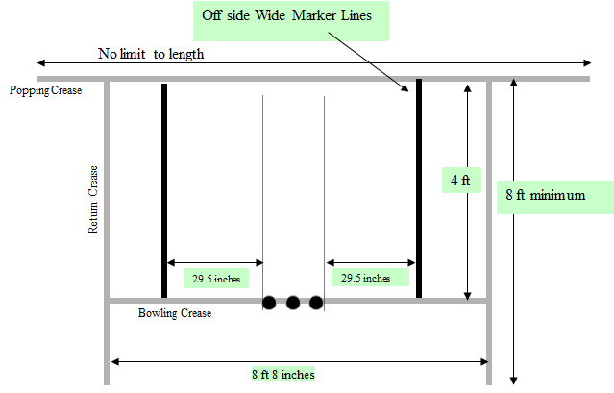

Section 3: Players

A match shall be played with a minimum of 8 players from each team.

3.1.) Late Arrival Penalty:
- At least 8 players from a team need to be present on the ground at least 10 minutes before the scheduled start time for play. If this requirement is not met then the following penalties are assessed as given below depending on how long the delay is from the 10 minutes before scheduled start point.
- Between 10 minutes before scheduled start and the scheduled start time: Opponent Captain will claim the toss.
- Between scheduled start time and 10 minutes later: 1 over is lost by delinquent team
- Between 10 minutes later and 20 minutes later than scheduled start time: 2 overs are lost by delinquent team
- Between 20 minutes later and 30 minutes later than scheduled start time: 3 overs are lost by delinquent team
- If a team is not present with at least 8 players 30 minutes after the scheduled start time, then the match is deemed to be conceded and the opponent will garner 20 points for a win.

3.2.) Substitutes:
- If one club has less than 11 players nominated for a match, the captain of this club can request the opposing Captain to take substitute fielders to make 11.
- The opposition captain’s approval is necessary for the fielding side to borrow fielders from the opposing team, for any reason. Up to 3 fielders can be borrowed at one time.
- If the opposing Captain agrees to provide one or more of his players as substitute fielders for a fielding side, the opposing Captain shall pick the members of his club to field for the other team. The requesting captain cannot object to the fielder being supplied.

3.3.) Clothing:
- If any player is not dressed as per the rules of the league – white shirt and white trousers (no shorts will be allowed), he will be immediately be asked to leave the field and not enter the playing area until he follows the dress code.

3.4.) Player Eligibility for playoffs:
- A player shall have played at least 1 game in the league round to be eligible to play in the playoff games if his team qualifies.

Section 4: Scoring
The Scoring Priorities for OCL Matches are given below:

Priority | App Name
1 | Use CricClubs App
2 | Use NX Cricket
3 | Use Paper Scorecard
- If using 2 or 3, send Summary score [Total Runs/Total wickets lost (Total Overs faced)] update to OCL Management after each innings is completed
- Captains should ensure that a mobile device with CricClubs and NX Cricket apps as well as paper scorecards are available at the field

Section 5: Extras

5.1.) No Ball

5.1.1.) Law 24 – No Ball:
- For the entire innings, the no ball penalty will be 1 run and an extra ball shall be bowled in the over.
- The delivery immediately following the any no ball infraction delivery will constitute a free hit. Both batsmen cannot be dismissed, off it, except by being Run Out,
- The fielding captain is not allowed to change the location of his fielders during the free hit except for the case where the batsmen have crossed during the no ball delivery, though restrictions of fielders outside the 30 yard circle prevailing at that point in the innings, will still apply.

5.1.2.) Bowling of High Full Pitches
- Any delivery, which passes or would have passed on the full above waist height of the striker standing upright at the crease, is a No Ball
- In the event of a bowler bowling a high full pitched ball as defined above (i.e. a beamer), the umpire at the bowler’s end shall, in the first instance, call and signal no ball and when the ball is dead, caution the bowler and issue a first and final warning. The umpire shall inform the other umpire, the captain of the fielding side and the batsmen at the wicket of what has occurred.
- Should there be any further instance by the same bowler in that innings, the umpire shall call and signal no ball and when the ball is dead direct the captain to take the bowler off forthwith. If necessary, the over shall be completed by another bowler, who shall neither have bowled the previous over, or part thereof, nor be allowed to bowl the next over, or part thereof.
- The bowler thus taken off shall not be allowed to bowl again in that innings.

5.2.) Wide Ball

5.2.1.) Law 25 – Wide Ball:
- Leg Side Wide Ball: Irrespective of where the ball pitches in relation to the stumps, if that ball passes down the leg side of the striker without touching any part of the person or equipment of the striker, the umpire shall call and signal a wide ball. (even if the striker makes an attempt to play the ball).

- Off Side Wide Ball: If a ball, not being a no ball, passes outside the "wide marker line" or crosses this line during its flight after having pitched outside the off stump, the umpire shall call and signal wide ball. Whether the batsman attempts to play the ball or brings it within reach is immaterial.

- No Ball to take precedence over a wide ball: Per the MCC Laws, a no ball call takes precedence over a wide ball call

5.2.2.) Penalties on Wide ball:
- The wide ball penalty will be 1 run. This penalty shall stand in addition to any other runs which are scored or awarded. An additional ball will need to be bowled in the over to make up for the wide ball call.

Section 6: Penalties

6.1.) Over-Rate penalties:
- All teams are expected to be in position to bowl the first ball of the last of their 30th over within 2 hours 20 minutes max (including the time for drinks breaks) after the start of the innings.
- If the innings is interrupted due to weather, injury or other unforeseen circumstances, the cessation time for that innings shall be re-calculated by the umpires based on the amount of time lost during the interruption(s).
- The Umpires must note the start and end time for each innings in every match they officiate in and submit it as part of their report to the OCL management. The OCL Management will review the report and make a call if a team was in violation of the over rate requirement slow over rate .
- For the first occurrence of such a violation by a team, the captain will be warned in writing. For every subsequent violation within the same tournament/competition, the captain of the team will be suspended one match, which will be the match immediately following the second violation.
- For the purposes of this law, the Captain of a team is the person who is identified on the team roster at the beginning of the season. If he is not part of the playing XI for the team in that match, then the captain is the person who is identified to the umpires at the toss for that match.
- Umpire's responsibility: The umpires are responsible for monitoring the speed of play and for enforcing this rule. They are also responsible for adjusting the innings time limit when interruptions, beyond the bowling sides control (e.g. injury), cause a stoppage in play, and shall inform the fielding captain of these adjustments as and when they occur. Additionally, the umpire shall inform the fielding captain how much time his team has left to start the 30th over, at the end of the 20th, 25th and 28th overs.
- For the purpose of net run-rate calculations, any runs accrued through application of this clause shall be included in calculations.

6.2.) Batting side Time wasting penalties:
- If the Umpire considers the batsmen to be un-necessarily wasting time, one warning will be given in an innings. This warning will continue to apply for the rest of the innings with the umpires informing every new batsmen of this. The second time that an umpire deems a batsman is wasting time, and for every subsequent instance thereafter, 6 runs shall be added to the total of the fielding side.

6.3.) Levying penalties and Arbitration:
- Umpire will have full power to levy penalties at the time of the game
- If a team is late to arrive to the game – For penalty see section 3.1
- If the home team does not prepare the ground for the game at least 15 minutes prior to the start of the game – section 13.1
- In case of any physical altercations or excessive sledging the umpire and match referee are in their rights to apply penalties as per the guidance in the table below “Penalty table for infraction against the Spirit of Cricket in the Oregon Cricket League”

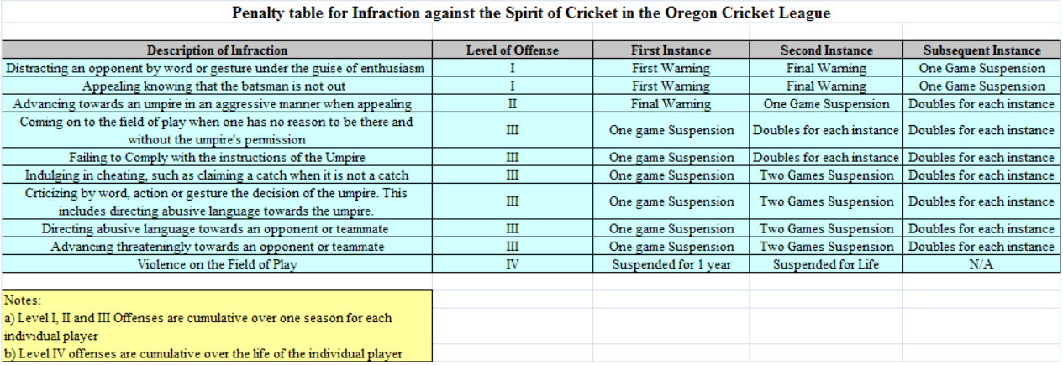
- The concerned party’s BOD member may appeal an on-field adjudication (and which does not involve #1, #2, #3 above) by the umpire in writing within 2 weeks of the incident to the OCL Management.
- For the special case of an entire team leaving the field of play as protest towards an umpire’s decision or any other reason, upon receipt of the umpire’s report on the incident, the captain of the team will be suspended for one match and the team will be fined $200, payable before 48 hours of the scheduled start time of the team’s next match.
- Final arbitration of penalties on any appeals will rest with the OCL management.

Section 7: Innings

7.1.) Number of Innings: The matches will consist of one innings per side, each innings being limited to a maximum of 30 overs.

7.2.) Length of Innings: In uninterrupted matches (i.e. matches which are neither delayed nor interrupted for weather or other reasons):
- Each team shall bat for 30 overs unless all out earlier.
- If the team fielding first fails to bowl the required number of overs by the scheduled time for the cessation of the first innings, play shall continue until the required number of overs has been bowled. Over Rate Penalties shall be applied (See section 6.1)
- If the team batting first is dismissed in less than 30 overs, the team batting second shall be entitled to bat for 30 overs.
- If the team fielding second fails to bowl 30 overs by the scheduled time for the cessation of the second innings, the hours of play for the match shall, subject to conditions of ground, weather and light, be extended until the required number of overs has been bowled or a result has been achieved. Over Rate Penalties shall be applied. (See section 6.1)

7.3.) Interval between Innings:
- The interval between Innings will be of 20 minutes duration.
- In circumstances where the side bowling first has not completed the allotted number of overs by the scheduled cessation time for the first innings, and extra time is used up to complete the 30 overs in that innings, the umpires shall reduce the length of the interval between the innings to 10 minutes.
- One break of 10 minutes shall be taken after the completion of the 15th over in each innings. On particularly hot days, the Captains have an option of deciding to take two breaks of 5 minutes each after the 12th and 24th over of the innings, provided this decision is made before the toss for innings and the umpires are informed of it before the start of play. Due to over rate issues, drink breaks can be foregone as decided by the umpires.

Section 8: Restrictions on Placement of Fieldsmen

- No more than 2 players may field behind square leg at any time.
- At the instant of delivery there shall not be more than five fieldsmen on the leg side.
- For the first 6 overs only of each innings, a maximum of only two fieldsmen are permitted to be outside an area bounded by two semi-circles centered on each middle stump (each with a radius of 30 yards) and joined by a parallel line on each side of the pitch (the fielding circle). The fielding circle should be marked by painted white 'dots' at five yard intervals, each 'dot' to be covered by a white plastic or rubber (but not metal) disc measuring seven inches in diameter.
- Batting Power Play will be overs 7 to 24 (18 overs), a maximum of only 4 fieldsmen are permitted to be outside the 30 yard fielding circle.
- Bowling Power Play will be overs 25 to 30 (6 overs), a maximum of only 5 fieldsmen are permitted to be outside the 30 yard fielding circle.
- In the event of an infringement, the square leg umpire "shall call and signal "No Ball".
- In circumstances where the number of overs for the team batting first is reduced in accordance with the table below.

Innings Duration | Mandatory | Batting | Bowling
29 | 6 | 17 | 6
28 | 6 | 17 | 5
27 | 6 | 16 | 5
26 | 5 | 16 | 5
25 | 5 | 15 | 5
24 | 5 | 14 | 5
23 | 5 | 14 | 4
22 | 5 | 13 | 4
21 | 4 | 13 | 4
20 | 4 | 12 | 4

- Where the number of overs for the team batting second is reduced, the restrictions above will apply for the same proportion of the second innings as applied in the first innings (fractions to be ignored).

Section 9: Interruptions of play

- If both teams have not played 30 overs or have not completed their innings (being all out) in the match, for reasons of ground, weather or light related interruptions, the Duckworth-Lewis Method will be used to calculate the run target for the team batting second.
- Rain curtailed games are treated as completed so long as at least 20 overs have been bowled in each innings.

Section 10: Result

- The team scoring the higher number of runs shall be the winner.
- If the scores are equal then the match result is a tie.

Section 11: Points

- Winning Team garners 20 points.

- Losing Team can get a maximum of 10 bonus points as follows:
- 1 point if 2 wickets have been taken in the opponent’s completed innings or before target run total reached
- 2 points if 4 wickets have been taken in the opponent’s completed innings or before target run total reached
- 3 points if 6 wickets have been taken in the opponent’s completed innings or before target run total reached
- 4 points if 8 wickets have been taken in the opponent’s completed innings or before target run total reached
- 5 points if 10 wickets have been taken in the opponent’s completed innings

- 1 point if team total of completed innings is between 40 and 69 runs
- 2 points if team total of completed innings is between 70 and 99 runs
- 3 points if team total of completed innings is between 100 and 129 runs
- 4 points if team total of completed innings is between 130 and 159 runs
- 5 points if team total of completed innings is 160 runs or more

- In case of a tie, as defined by the scores being level after both teams’ innings have been completed, each team gets 10 points plus the bonus points as stated above.

- A team conceding a match will be deducted 15 points. The team to which a match is conceded will be considered the winner of the match and will be awarded 20 points.

- If, due to weather interruptions, the two innings are of un-equal overs, then the result of the match will be decided by the scoring rate per over, with the side having the larger scoring rate being declared the winning side. (In such a scenario, the bonus points shall be prorated to 30 overs, that is, if both innings are of equal length in terms of overs, the bonus points shall be calculated by scaling the bonus points actually obtained by the ratio of {30/actual overs per innings}…and rounding off (up or down) to the nearest whole number. If the innings are of different number of overs then bonus points for batting and for bowling are considered separately… each is scaled up to a 30 overs scenario (without rounding off) then the sum is rounded off (up or down) to the nearest whole number.)

Section 12: Determination of Standings

The Teams shall be ranked in the League Table according to the following tie breaker hierarchy:

- Average points per completed match (to the second decimal place).
- If two teams are tied for average points per completed match, then the team with the total points garnered in the match(es) between the two teams will be the higher ranked team. If the teams have the same number of points in these head-to-head matches then the 3rd tie breaker below (Net Run Rate in all completed matches) will apply.
- If three or more teams are tied for average points per completed match, the net run rate for all completed matches will decide the ranking between these teams. Higher net run rate results in a higher ranking.

Section 13: Miscellaneous

13.1.) Start of play:
- The starting times for the matches are specified in the schedule published by the OCL management. The Captains can change this starting time by mutual agreements, except for cases where two or more matches are scheduled on the same day on the same field.
- The Captains should make arrangements to be in contact with each other via telephone on the morning of the match, lest the start of the match is affected by weather or travel delays. The captain of the home club shall be accessible via phone or otherwise within 60 minutes of the scheduled starting time of the match.
- If the visiting club cannot make it to the ground 15 minutes before the scheduled start of play, then the home club should be informed of this at least 30 minutes before the start of play. Failure to do this will result in the visiting club being penalized for late arrival as given in Section 3.1.
- If the match does not start on time for reasons of ground and/or pitch not being prepared, or the home club members not being present on the ground, then the home club will be penalized as indicated in Section 3.1.
13.2.) Protective Equipment:
- All protective equipment usually worn under clothing (thigh pad, box, chest guard, etc) must be worn under clothing and not visible to the umpires. If a batsman wears such equipment in view, the umpires must instruct him to either wear it under his clothing or remove it altogether. Failure to concede to this request shall be treated, as a mark of indiscipline and the umpire must report the player to the league.

13.3.) Wicket is down:
- When Spring-back Stumps are used, it is not possible to strike the stumps out of the ground as is required by Law when both bails are off. In such a case, the decision as to when a stump is struck out of the ground is one for the umpires to decide on the facts before them.
- When Spring-back Stumps are used, the bails are often dislodged when the ball hits the cast iron support base of the stumps. If this is so, the bails will not be considered dislodged and the wicket is not down for the purposes of this Law.

13.4.) Number of over per bowler:
- No bowler may bowl more than six overs. If there is a reduction in the number of overs before the match has started (as defined by ‘Play‘ being called by the Umpire), the maximum number of overs bowled by a bowler will be calculated by dividing the number of overs to be bowled per innings by 5 and rounded up to the nearest whole number.
- In the event of a bowler breaking down and being unable to complete an over, the remaining balls will be bowled by another bowler. Such part of an over will count as a full over only in so far as each bowler's limit is concerned.

13.5.) Law 31 – Timed out:
- Law 31 will not apply. However, the incoming batsman must be in position to take guard or for his partner to be ready to receive the next ball within 2 minutes of the fall of the previous wicket. If this requirement is not met, the batsmen will be warned for Time Wasting. See Section 6.2. Note: The batsman next in, is expected to be waiting just outside the boundary and to be ready to make his way to the wicket immediately when a wicket falls.

13.6.) Umpires:
- One Neutral umpire will be provided for all the matches by OCL.
- The batting team shall provide the Striker’s end umpire (leg umpire). The requirement is that the umpire should have been a player in the OCL for at least 3 full seasons or played in at least 15 OCL matches.
- Umpire fees will be collected as part of the team dues and paid to the individual umpires by the OCL Management. Batting team umpires are not paid.
- Please note that per the Laws of Cricket, the latest time at which the toss should take place is 10 minutes before the scheduled start of the match

13.7.) Balls:
- Four piece red balls, approved by OCL, shall be used for the T30 Tournament
- A new ball shall be used at the start of each innings.
- If a team does not have a new ball of the acceptable make, they shall purchase one (from the opposing team or anyone else who has one) before taking the field.

13.8.) Declarations:
- The Captain of the batting side may not declare his innings closed at any time during the course of a match.

13.9.) Cancellations due to Weather:
- For matches between teams in the same Metropolitan area, the Captains (or their representatives) from the two teams shall inspect the ground the day before the match. If, based on present field conditions and weather forecasts, a decision is reached at that time to abandon the match then the Umpire/ Match Referee shall be informed of it. If the Captains do not agree on a decision at that time to abandon the match, then the decision will be postponed to the morning of the match, one hour before its scheduled start.
- If a decision is reached at that time to abandon the match, then that decision is final, and the Umpires should be informed of it promptly. If, at that time the Captains still do not agree and there are no neutral umpires present, then the Home Captain’s decision is final. If neutral umpires are present, then they shall make a decision and inform the Captains.
- To help the Umpire with the decision making process, the following guidelines are made available.
- Level 1: Suitable – perfectly acceptable.
- Level 2: Unsuitable – not ideal for play, but not actually dangerous. Play may or may not take place, depending upon agreement by captains. If both captains agree then the umpires are over-ruled in this case and play continues. Even if one captain disagrees then play is stopped.
- Level 3: Unreasonable or dangerous – any reasonable person could foresee the likelihood of injury to those on the field of play. Umpires will not allow play to take place. Captains have no say.
- Per the Laws, after the toss of innings, the umpires are the sole judges of the weather and other conditions, and the decision to abandon a match rests with the umpires. If neutral or dedicated umpires are not present, then the Captains shall be the sole judges of the conditions. If they cannot agree then the status quo will continue.

Section 14: Tournament Format
Round Robin Phase:
- Randomly Truncated 16 team Round Robin format of 8 matches per team.

Play-offs Phase:
- Super 6 Format for top and bottom 6 teams in the Points table after the completion of the Round Robin phase.
- These formats are given below.

- 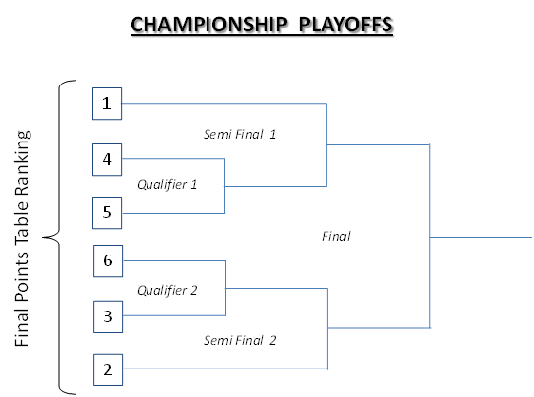

- If there is no result in any of the play-off matches due to weather, except the Finals, the higher seed progresses to the next round.

- The Final can be replayed once if there is no result due to weather or other reasons. If the Final cannot be completed for whatever reason, the two finalists will be declared Joint-Winners

Section 14: Tournament Scheduling
Frequency of Matches Scheduled
- Wherever possible, teams shall not be scheduled to play more than one match in a single weekend.
- However, in case of rained out matches and Playoffs, teams may be required to play more two matches in a single weekend but only one match per day will be scheduled for a team.

Scheduling of Rained-out Matches
- Rained-out matches in the Round Robin phase will be re-scheduled once, during a future weekend, in the match slots identified on the schedule. A rained-out rescheduled match, that gets rained out in its re-scheduled slot, will not be re-scheduled a second time.
- When there a rained-out matches in a weekend, the updated schedule with the re-scheduled rained out matches, will be published by the end of Monday following that weekend.

