

**Rules for Ramadan Cup 2017** (Session 4)

Agreement Number: **AG0301**

**Tournament**

* Ramadan Cup 2017 is organized by S.H.S Cricket Board.
* Chairman of Ramadan Cup is Abdul Samad Bhutto.
* Tournament is strictly for players under 19.
* In Final of the tournament Board will provide transport with 50% for the players by careem.
* The matches will be played according to schedule.
* The Inning contains 12 overs.
* Each team will play at least 3 matches.
* 4 teams are participating in this tournament.
* If there is any fight between two teams then only the Captains and Umpire will solve the fight. Other players must not interfere.
* There are two playoffs in this tournament and one Final.
* Registration Fees is not Refundable.

**Ground**

S.H.S Cricket Stadium, Near Quba Mosque, Prince Abdul Mushin bin Abdul Aziz Road, Medina, Saudi Arabia.

**Laws**

**Limit for overs**

* 3 overs are limited to each bowler.
* Each over must be completed in 5 minutes or the batting team will get extra one run for the number of balls left.

**Methods for taking Wicket**

* Bowled
* Stump
* Run-out
* Caught-out

**Note:** LBW is not out.

**Boundaries**

* Four
* Six
* Players who are not playing are not allowed to enter the field.

**No Balls**

* No balls According to ICC Law
* Bending of Arm.
* Chucking or Throwing of ball is an illegal action.

**Declaration**

* Batsman can be declared.
* Bowler can’t be declared.

**Over Throw**

* Over Throw Runs will be applied.

**Bouncer Warning**

* Umpire will warn the bowler on the bouncer.
* After Umpire warns the bowler, the next bouncer will be No Ball in that over.

**Red Card**

* Red card be only be given by Umpire.
* Red card will be given to players if they use bad language/ fight/ show disrespectful behavior.

**Last Man**

* Last batsman can not bat.

**Bowlers Allowed**

* Fast
* Medium Fast
* Spin

**Decisions**

* Umpire’s Decision is Final Decision.

**Accessories Allowed for Safety**

* Wicket Keeper Gloves (Only for Wicket Keeper).

**Communication Systems**

* Mobile phones are not allowed in the ground boundaries.
* Players can keep their Mobile phones and other accessories in our safe.
* System is allowed only for Umpires.

**Transport**

* S.H.S Cricket Board is not responsible for the transport of the players.
* In Final Board provide the transport for the winner team.

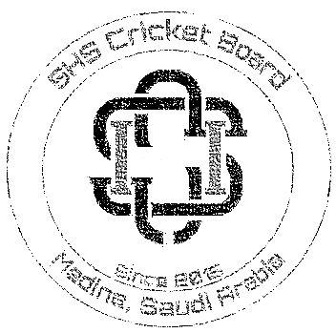

Chairman RC 2017 Chairman SHS Cricket

***Abdul Samad Bhutto Muhammad Hamza Mughal***