SOCIETY PREMIER LEAGUE – SEASON 2

RULES AND REGULATIONS

Teams and Clothing
- A Team should have a minimum of 6 players to play the match and a maximum of 8 players in a match. Only 6 players can be used on the field (only 6 while batting and 6 while bowling)
- 2 super-substitutes are allowed per match. (Super-Substitutes – Two substitute players who can be brought after the end of the first innings. Super Sub can bowl/bat based on the stage they are brought in)
- Minimum age of the players should be 15 years as of Jan 2017
- It’s a Men’s tournament
- The team selected to play for the match should be given at the time of the toss.
- Clothing – Each team can have their own colored sports clothes. Sports shoes are mandatory.
- Following attires are not allowed:
  - Jeans/ Formal Pants
  - Slippers/Sandals/Bare foot
  - Formal shirts
  - Gloves
- All the team member details to be provided to the organizer by December 5th, 2017. December 5th will be the lock day for all teams. Hence you cannot add or update the team after December 5th 2017. Kindly request every team to cooperate on this.

Groups and Points
- The number of teams participating will be 18
- The Group stage will consist of 6 groups (A, B, C, D, E, F) with 3 teams each. During the Round-Robin stage each team will play the opposing teams in their pool once. (A total of 2 league matches for every team)
- Points - Winner 2 (two) points, Looser 0 (zero) points.
- There is no Bonus point
- Table topper along with 2 other teams with best NRR will move to the Super 8 stage (Knockouts).
- Winners of each knockout game will move to Semi-finals.
- Grand Finals would be between the winners of each semi-final Teams
- Grouping will be done on December 5th, 2017 using lottery (Would be telecasted live on our YouTube channel). Since it’s a 3 days event, League matches will be on 10th and 16th December. Be aware that, few matches might be played under flood lights.

NOTE: All details will be maintained in our site, https://cricclubs.com/tvistsports

Toss, Time-keeping, Scoring and Penalties:
Each team must be prepared in advance for each match as follows:

- Captains must conduct the toss at least 15 minutes prior to the scheduled start of the game and notify the TVIST Crew of the team selection (playing 6 and super subs)
- Teams fielding first should be ready to take the field before the conclusion of the preceding game
- Each team will be given a total of 20 minutes (maximum) to complete bowling their 6 overs.
- If the 6 overs are not completed by the allocated time, umpires/organizer shall apply penalties (e.g., Reducing of Overs/ Increase of target based on circumstances)
- Delays due to injuries etc. will be taken into consideration for timing purpose
- League Organizer will have a dedicated scorer for all the matches and Scoring will be done through CricClubs Mobile app. Every team can see their live scores in the app itself.
- Manual scoring will be done, in case of server issues. But scorecard will be uploaded as soon as the server is up.

Scoring Zones and Special rules:
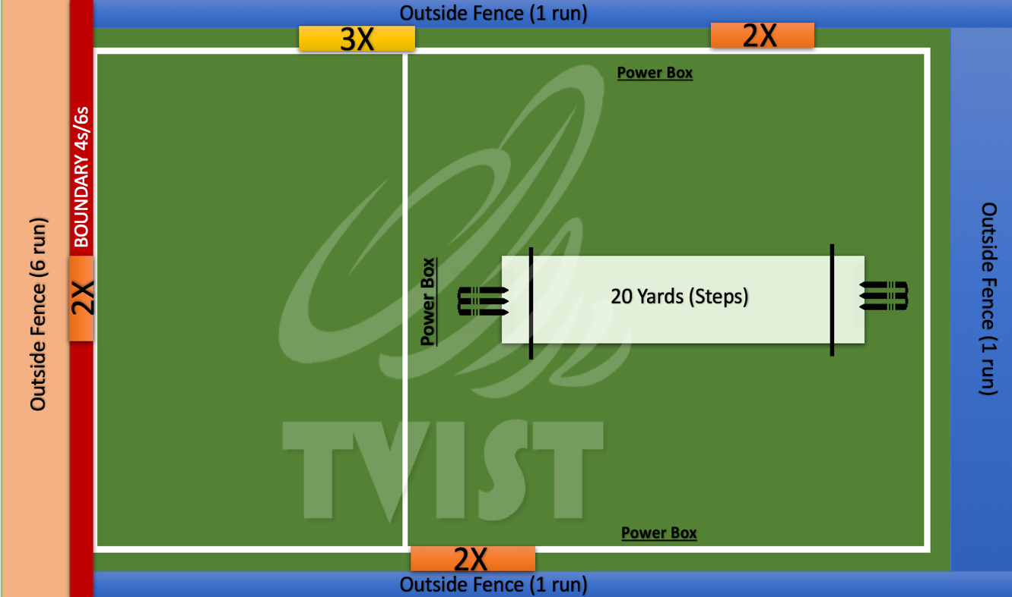
- 2X and 3X Region
2X - Orange 3X - Yellow
When the ball is played in this region (first impact), runs taken will be multiplied. E.g., when played over 2x region, Total Runs = 2 X Runs taken. Similarly, when played over 3X region Total Runs = 3 X Runs taken
Note: When a Batsman takes "Super Ball", 2X and 3X zones are not applicable. Runs scored on a Batsman Super Ball, will be doubled by default. In Season 2, one 2X region is set on the boundary. Hence a 4 run would result to 8 runs and a 6 run would result to 12 runs
- TVIST SUPERBALL
Every team can take one superball during Bowling and one during Batting.
So what happens when a TVIST Superball is applied?
  - Batsman takes the Superball: When a batsman applies superball, runs scored off that ball will be doubled. E.g., Batsman scores a 4 of the superball gets 8 runs added to the scoreboard. Note: When a Batsman takes "Super ball", 2X and 3X regions are not applicable. Last ball of the final over (6th over) will be declared Batsman Superball by default, if it was not applied anytime during the innings.
  - Bowler takes the Superball: When a bowler applies superball, and picks up a wicket, bowler gets a wicket and -4 runs on the opponent’s scorecard. Note, if the batsman hits the ball over the fence (excluding Straight boundaries), he will be declared OUT. Second last ball of the final over (i.e., 5th delivery of the final over) will be declared Bowler Superball by default, if it was not applied anytime during the innings.

Note: If a Wide or No-ball or any illegal deliveries are bowled, the Superball stays for the next delivery. But runs for Wide and No ball will be 1 run only. Superball is considered complete only after a legal delivery.

- Outside Fence:
When the ball is played Outside Fence, only one run will be declared. This is to avoid extra times and encouraging the players to play within the field. If the ball goes through the fence, the result will be same.

- Boundary and Outside Fence over Boundary Line:
When the ball is played to the boundary region and over the boundary region (Straight boundaries only), 4 and 6 runs will be given. (Similar to regular cricket boundaries). If the ball is hit over the straight boundary, it will be declared SIX.

- Power Box:
First over of the match will be a power play by default. Only one Fielder can be outside the Power Box and 4 Fielders inside the Power Box. Bowler can take his run up outside Power Box.

Pitch and Ground
- Pitch length: 20 yards
- Ground is covered with Astro turf and fence

Equipment’s:
Every team should bring their own playing equipment’s (Only Bats), Organizer will provide Stumps and New or Used balls for each match

General Playing Guidelines
Bowling:
- An over shall consist of a maximum 6 legal deliveries
- Chucking is not allowed. (if a bowler is found chucking Umpires will give a warning to the bowler, if again found chucking, the ball will be declared as no ball and the bowler will not be allowed to bowl again. In addition to this, if the batsman’s feels the bowler is chucking, He should inform the Umpires, from then umpires will have a watch on the bowler. If found chucking, rules will be applied as mentioned. If umpires are fine with it, the game should continue without any issues. Any unruly behavior will not be encouraged. If things go out of hand, Umpires will call off the match and have the authority to decide the winner of the game)
- Only two bowlers can bowl a maximum of 2 overs and the remaining overs shall be bowled by other bowlers – 1 over each (4 bowler’s mandatory per team).
- The standard wide pitch-markings on either side of center stumps will apply
- A “Wide” and a “No-ball” (Crease, Waist height and Shoulder height) shall count as 1 runs and an extra ball shall be bowled.
- Subsequent delivery of a “No-ball” shall be FREEHIT. During a FREEHIT, all the fielders shall be inside the POWERBOX, no fielders are allowed to field outside the POWERBOX.
- If a bowler gets injured while bowling their over shall have another bowler complete the over by a player selected by the batsman on strike.
- No bowler shall bowl 2 consecutive overs
- Only one bouncer is allowed in an over and the bowler shall be given a warning. Subsequent bouncer shall be declared a “Wide” or “No-ball” based on height
- The ball bowled above the waist height to the batsman without a bounce will be a NO BALL
- LEG BYES are not applicable.
- BYES applicable

Batting:
- A run is considered complete only when both the bats successfully crosses their ends. If unsuccessful, no runs will be awarded.
- While attempting for more than one run, both the batsman should reach/touch the crease of either ends, if not, it will be awarded one run short (on a 2-run attempt)
- Only a successful run is considered for 2X and 3X zones.

Wicket Keeper
- Wicket keeper is optional during the game
- Wicket keeper is not allowed to wear gloves
- In case fielding team opts not to use a wicket-keeper following rules applies for Batsman
  - Batsman can attempt a run of BYEs, if he attempted to play the ball and he missed it
  - Batsman cannot attempt a run of BYEs, is he desperately leaves the ball

Fielding:
- If a fielder gets injured during the course of play, a substitute fielder will be permitted, but he/she will not be allowed to bowl or bat. At bat, the injured player shall be entitled to use a “By-Runner”
- A fielder can dismiss the batsman by a successful Catch or Runout.
- Overthrows are applicable. Overthrow on a 2X or 3X region will not multiply runs. (2X and 3X is only applicable on first impact of the ball)

Wickets/Dismissals:
- Following dismissals are applicable,
  - Bowled
  - Catch
  - Stumping
  - Runout
  - Obstructing the Field (when a batsman intentionally blocks the fielding team)
  - Hit wicket
  - Balls hit Outside the fence (Right-side, Left-side and Back-side) on a “Bowling Superball”
- Following dismissals are not applicable,
  - LBW
  - Runout non-striker before delivering a ball (warning shall be awarded the non-striker on notification to the umpire. Subsequent warning will lead to negative scoring (-2 runs) which shall only be decided by the Umpire)
  - Balls hit Outside the fence (Right-side, Left-side and Back-side) on a “Batting Superball”

On Field Decisions:
- Decisions made in all matters by the Umpire on the field of play shall be final.
- Organizer cannot change an on-field call
- In case on field umpire needs some clarification on rules or any decision, He can approach the organizer for advice
- Other than 2 on field umpires, Technical panel on the commentary panel shall be the Line Umpires (to observe on boundary lines). In case, the on-field umpire need an input from the line umpires, he shall approach them.
- Any unruly behavior on the field will not be encouraged, Umpire/Organizer reserve all rights to disqualify the entire team from the tournament.
- We would request Fair Play from each of the teams participating

Results:
- The side having achieved the highest score at the completion of the match shall be declared the winner.
- In the event of tie, a Bowl-out (Best of 3) will determine the winners.
- In the event of both the teams remain tied upon consideration of items 1 and 2, the team losing fewer wickets shall be judged the winners
- In case of a tie even after Items 1,2 and 3, the winner will be selected by the toss of a coin

Awards and Recognition:
- Winners will receive the winner’s trophy along with a cash prize of Rs.10000/- and individual medals for each player
- Runners will receive the Runner’s trophy along with a cash prize of Rs.5000/- and individual medals for each player.
- Based on the tournament statistics maintained in CricClubs.com, Topper of the Batting Records and Topper of the Bowling Records will receive Best Batsman and Best Bowlers trophies accordingly.
- Man-of the Match will receive a MoM trophy for every match, which will be given as soon as each match completes

Interruptions:

- Any interruptions because of any major injuries is subjective and organizer will take care of managing the time and schedule
- In case of rain before a match starts, the match will be rescheduled according after the ground is playable.
- In case rain interrupts the game in progress, the match will continue as soon as the rain stops and ground is playable. If not the match will be started free on a playable time.
- In case the ball in play goes lost during the match, a used ball (based on availability) or a new ball will be provided to continue the game.

Society Premier League Season 3:

- SPL shall be a quarterly event
- So, SPL Season 3 will happen in the month of March,2017 or April,2017
- Team records of each season will be maintained in our website

Note by the organizer

This event is dedicated to Teams representing a Society. TVIST considers, each Society as a Franchise and Trust is the key factor as of now. In the spirit of the game, we are bound to trust each other. TVIST team is working hard to figure out a way to building this tournament into a Major league for societies in Bangalore. This could result in lot of transformation in the coming seasons. TVIST is committed to deliver the best sporting experience to our customers. Looking forward for your cooperation. Thank you

CONTACT US IF YOU HAVE ANY QUERY... WE ARE HAPPY TO HELP!!!

